**Customer Spending Behavior Classification using Online Shopping Data: A KDD Approach**

#### 

#### Project Report

Submitted to the Faculty of Engineering of

**JAWAHARLAL NEHRU TECHNOLOGICAL UNIVERSITY KAKINADA, KAKINADA**

In partial fulfillment of the requirements for the award of the Degree of

## BACHELOR OF TECHNOLOGY

## In

## COMPUTER SCIENCE AND ENGINEERING

By

**BOLLU SNIGDHA (22481A0535)**

**DONGARA YASWANTH (22481A0553)**

**GARIKIPATI TRIPURA (22481A0558)**

**GOLI PRABHAS (22481A0560)**

Under the Enviable and Esteemed Guidance of

**Dr. M. Babu Rao**, **M.Tech, Ph.D.,** **Head of the Department**



## DEPARTMENT OF COMPUTER SCIENCE AND ENGINEERING

**SESHADRI RAO GUDLAVALLERU ENGINEERING COLLEGE**

**(An Autonomous Institute with Permanent Affiliation to JNTUK, Kakinada)**

**SESHADRIRAO KNOWLEDGE VILLAGE**

**GUDLAVALLERU – 521356**

**ANDHRA PRADESH**

### 2024-25

**SESHADRI RAO GUDLAVALLERU ENGINEERING COLLEGE**

**(An Autonomous Institute with Permanent Affiliation to JNTUK, Kakinada)SESHADRI RAO KNOWLEDGE VILLAGE, GUDLAVALLERU**

**DEPARTMENT OF** **COMPUTER SCIENCE AND ENGINEERING**



**CERTIFICATE**

This is to certify that the project report entitled **“Customer Spending Behavior Classification using Online Shopping Data": A KDD APPROACH”** is a bonafide record of work carried out by **B. Snigdha (22481A0535), D.Yaswanth(22481A0553), G.Tripura(22481A0558), G.Prabhas (22481A0560),** under the guidance and supervision **Dr. M. Babu Rao**, **M.Tech, Ph.D.,** **Head of the Department,** Computer Science and Engineering, in the partial fulfillment of the requirements for the award of the degree of Bachelor of Technology in Computer Science and Engineering of Jawaharlal Nehru Technological University Kakinada, Kakinada during the academic year 2024-25.

**Project Guide Head of the Department (Dr. M. BABU RAO) (Dr. M. BABU RAO)**

**External Examiner**

## ACKNOWLEDGEMENT

The satisfaction that accompanies the successful completion of any task would be incomplete without the mention of people who made it possible and whose constantguidance and encouragements crown all the efforts with success.

We would like to express our deep sense of gratitude and sincere thanks to **Dr. M. Babu Rao**, **M.Tech, Ph.D.,** **Head of the Department,** Computer Science and Engineering for his constant guidance, supervision and motivation in completing the project work.

We feel elated to express our floral gratitude and sincere thanks to **Dr. M. Babu Rao**, **M.Tech, Ph.D.,** **Head of the Department**, Computer Science and Engineering for his encouragements all the way during analysis of the project. His annotations, insinuations and criticisms are the key behind the successful completion of the project work.

We would like to thank our beloved principal **Dr. B. KARUNA KUMAR, M.Tech, Ph.D.,** for providing a great support for us in completing our project and giving us the opportunity for doing project.

Our Special thanks to the faculty of our department and programmers of our computer lab. Finally,we thank our family members, non-teaching staff and our friends, who had directly or indirectly helped and supported us in completing our project in time .

Team Members

**B.SNIGDHA(22481A0535) ,**

**D.YASWANTH(22481A0553 ),**

**G.TRIPURA (22481A0558),**

**G.PRABHAS(22481A0560)**

|  |  |
| --- | --- |
| **INDEX** |  |
| **CONTENTS** | **PAGE NO** |
| **Abstract** | 1 |
| **PART A: KDD PROCESS** | 2-34 |
| **Chapter 1: Introduction** | 2-8 |
| 1.1 Introduction to KDD |  |
| 1.2 Data Warehousing |  |
| 1.3 Data Mining |  |
| **Chapter 2: Data Mining and Warehousing Process on Collected Dataset** | 9-30 |
| 2.1 Problem Statement |  |
| 2.2 Methodology |  |
| **Chapter 3: Experimental Analysis** | 31-34 |
| 3.1 Evaluation |  |
| 3.2 Conclusion |  |
| **PART B: DATA MINING IN DETAIL** | 35-44 |
| **Chapter 1: Introduction on data mining methodology** | 35-36 |
| 1.1 Problem Statement |  |
| 1.2 Identification of appropriate methodology |  |
| **Chapter 2: Analysis on Dataset** | 37-38 |
| **Chapter 3: Working on Dataset** | 39-45 |
| **Chapter 4: Experimental Analysis** | 46-49 |
| **PART C: FINAL ANALYSIS** | 50-51 |
| **Evaluation of Experimental Analysis** | 50 |
| **Conclusion** | 51 |
| **References** | 52 |
| **List of Program Outcomes and Program Specific Outcomes** | 53-54 |
| **Mapping of Program Outcomes with graduated POs and PSOs** | 55 |

## 

## ABSTRACT

## In the age of digital transformation, online shopping has become a dominant force in the global retail industry. With the exponential growth of e-commerce platforms, analyzing consumer behavior, sales patterns, and market trends has become crucial for businesses to enhance decision-making and optimize their strategies. This project focuses on leveraging data mining techniques using the Orange tool to extract valuable insights from online shopping datasets. The study applies a range of machine learning techniques, including classification, clustering, and association rule mining, to identify customer purchasing patterns, product popularity, and sales trends.

## The implementation involves preprocessing raw data by handling missing values, normalizing features, and selecting relevant attributes for analysis. Various clustering methods such as K-Means and hierarchical clustering are employed to segment customers based on purchasing behavior. Classification algorithms like decision trees, Naïve Bayes, and support vector machines (SVM) are utilized to predict customer preferences and future purchasing decisions. Additionally, association rule mining (Apriori algorithm) helps uncover frequently bought item combinations, enabling businesses to improve cross-selling strategies.

## Through interactive visualizations and statistical analysis, the project provides an intuitive representation of key findings, allowing businesses and stakeholders to make informed decisions. Metrics such as precision, recall, F1-score, and accuracy are used to evaluate model performance, ensuring the reliability of the extracted insights. Furthermore, the study explores real-world applications of data mining in e-commerce, including personalized recommendations, fraud detection, and demand forecasting.

## By integrating theoretical data mining concepts with practical implementation, this research highlights the significance of data-driven strategies in the online shopping industry. The results emphasize how machine learning techniques can enhance customer engagement, optimize inventory management, and drive business growth. Ultimately, this project showcases the Orange tool's potential in simplifying complex analytical processes, making data mining accessible even to users with minimal programming expertise.

## PART A: KDD PROCESS

## CHAPTER 1: INTRODUCTION

* 1. **INTRODUCTION TO KDD**

Knowledge Discovery in Databases (KDD) refers to the complete process of uncovering valuable knowledge from large datasets. It starts with the selection of relevant data, followed by preprocessing to clean and organize it, transformation to prepare it for analysis, data mining to uncover patterns and relationships, and concludes with the evaluation and interpretation of results, ultimately producing valuable knowledge or insights. KDD is widely utilized in fields like machine learning, pattern recognition, statistics, artificial intelligence, and data visualization.

The KDD process is iterative, involving repeated refinements to ensure the accuracy and reliability of the knowledge extracted. The whole process consists of the following steps:

1. Data Selection
2. Data Cleaning and Preprocessing
3. Data Transformation and Reduction
4. Data Mining
5. Evaluation and Interpretation of Results

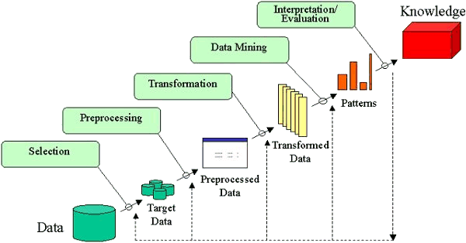

**Data Selection**

Data Selection is the initial step in the Knowledge Discovery in Databases (KDD) process, where relevant data is identified and chosen for analysis. It involves selecting a dataset or focusing on specific variables, samples, or subsets of data that will be used to extract meaningful insights.

* It ensures that only the most relevant data is used for analysis, improving efficiency and accuracy.
* It involves selecting the entire dataset or narrowing it down to particular features or subsets based on the task’s goals.
* Data is selected after thoroughly understanding the application domain.

By carefully selecting data, we ensure that the KDD process delivers accurate, relevant, and actionable insights.

**Data Cleaning**

In the KDD process, Data Cleaning is essential for ensuring that the dataset is accurate and reliable by correcting errors, handling missing values, removing duplicates, and addressing noisy or outlier data.

* **Missing Values:**Gaps in data are filled with the mean or most probable value to maintain dataset completeness.
* **Noisy Data:**Noise is reduced using techniques like binning, regression, or clustering to smooth or group the data.
* **Removing Duplicates:**Duplicate records are removed to maintain consistency and avoid errors in analysis.

Data cleaning is crucial in KDD to enhance the quality of the data and improve the effectiveness of data mining.

**Data Transformation and Reduction**

Data Transformation in KDD involves converting data into a format that is more suitable for analysis.

* **Normalization**: Scaling data to a common range for consistency across variables.
* **Discretization**: Converting continuous data into discrete categories for simpler analysis.
* **Data Aggregation**: Summarizing multiple data points (e.g., averages or totals) to simplify analysis.
* **Concept Hierarchy Generation**: Organizing data into hierarchies for a clearer, higher-level view.

Data Reduction helps simplify the dataset while preserving key information.

* **Dimensionality Reduction** (e.g., PCA): Reducing the number of variables while keeping essential data.
* **Numerosity Reduction**: Reducing data points using methods like sampling to maintain critical patterns.
* **Data Compression**: Compacting data for easier storage and processing.

Together, these techniques ensure that the data is ready for deeper analysis and mining.

**Data Mining**

Data Mining is the process of discovering valuable, previously unknown patterns from large datasets through automatic or semi-automatic means. It involves exploring vast amounts of data to extract useful information that can drive decision-making.

Key characteristics of data mining patterns include:

* **Validity**: Patterns that hold true even with new data.
* **Novelty**: Insights that are non-obvious and surprising.
* **Usefulness**: Information that can be acted upon for practical outcomes.
* **Understandability**: Patterns that are interpretable and meaningful to humans.

In the KDD process, choosing the data mining task is critical. Depending on the objective, the task could involve classification, regression, clustering, or association rule mining. After determining the task, selecting the appropriate data mining algorithms is essential. These algorithms are chosen based on their ability to efficiently and accurately identify patterns that align with the goals of the analysis.

**Evaluation and Interpretation of Results**

Evaluation in KDD involves assessing the patterns identified during data mining to determine their relevance and usefulness. It includes calculating the “interestingness score” for each pattern, which helps to identify valuable insights. Visualization and summarization techniques are then applied to make the data more understandable and accessible for the user.

Interpretation of Results focuses on presenting these insights in a way that is meaningful and actionable. By effectively communicating the findings, decision-makers can use the results to drive informed actions and strategies.

### 1.2 DATA WAREHOSUING

### A data warehouse is a centralized system used for storing and managing large volumes of data from various sources. It is designed to help businesses analyze historical data and make informed decisions. Data from different operational systems is collected, cleaned, and stored in a structured way, enabling efficient querying and reporting.

* Goal is to produce statistical results that may help in decision-making.
* Ensures fast data retrieval even with the vast datasets.

### Need for Data Warehousing

### 1. Handling Large Volumes of Data: Traditional databases can only store a limited amount of data (MBs to GBs), whereas a data warehouse is designed to handle much larger datasets (TBs), allowing businesses to store and manage massive amounts of historical data.

### 2. Enhanced Analytics: Transactional databases are not optimized for analytical purposes. A data warehouse is built specifically for data analysis, enabling businesses to perform complex queries and gain insights from historical data.

### 3. Centralized Data Storage: A data warehouse acts as a central repository for all organizational data, helping businesses to integrate data from multiple sources and have a unified view of their operations for better decision-making.

### 4. Trend Analysis: By storing historical data, a data warehouse allows businesses to analyze trends over time, enabling them to make strategic decisions based on past performance and predict future outcomes.

### 5. Support for Business Intelligence: Data warehouses support business intelligence tools and reporting systems, providing decision-makers with easy access to critical information, which enhances operational efficiency and supports data-driven strategies.

### Components of Data Warehouse

### The main components of a data warehouse include:

* Data Sources: These are the various [operational systems,](https://www.geeksforgeeks.org/difference-between-operational-systems-and-informational-systems/) databases, and external data feeds that provide raw data to be stored in the warehouse.
* ETL (Extract, Transform, Load) Process: The [ETL process](https://www.geeksforgeeks.org/etl-process-in-data-warehouse/) is responsible for extracting data from different sources, transforming it into a suitable format, and loading it into the data warehouse.
* Data Warehouse Database: This is the central repository where cleaned and transformed data is stored. It is typically organized in a multidimensional format for efficient querying and reporting.
* Metadata: [Metadata](https://www.geeksforgeeks.org/what-is-metadata/)describes the structure, source, and usage of data within the warehouse, making it easier for users and systems to understand and work with the data.
* Data Marts: These are smaller, more focused data repositories derived from the data warehouse, designed to meet the needs of specific business departments or functions.
* OLAP (Online Analytical Processing) Tools: [OLAP tools](https://www.geeksforgeeks.org/olap-servers/) allow users to analyze data in multiple dimensions, providing deeper insights and supporting complex analytical queries.
* End-User Access Tools: These are reporting and analysis tools, such as dashboards or [Business Intelligence (BI) tools](https://www.geeksforgeeks.org/what-is-business-intelligence/), that enable business users to query the data warehouse and generate reports.

**1.3 DATA MINING**

Data mining is a process of discovering patterns and knowledge from large amounts of data, utilizing sources such as databases, data warehouses, the internet, and other data repositories. It combines techniques from statistics, artificial intelligence, and machine learning to analyze large datasets and extract meaningful information. This analysis helps identify trends, correlations, and patterns that are not immediately obvious, enabling informed decision-making and predictions.

One of the key breakthroughs in data mining is its ability to handle and analyze big data efficiently. With the increasing volume, velocity, and variety of data, traditional methods are often insufficient. Data mining techniques like clustering, classification, regression, and association rule learning are essential for extracting valuable insights from complex datasets quickly and accurately.

Data mining is closely related to machine learning and data analytics. While data mining focuses on discovering new patterns within large datasets, machine learning involves developing algorithms thatcan learn from and make predictions on data. These fields complement each other, enhancing data analysis and predictive modeling capabilities.

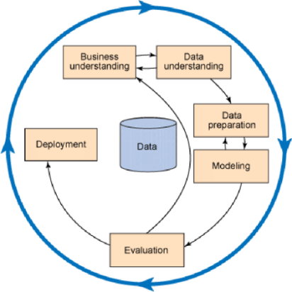

Data Mining Block Diagram

The data mining block diagram starts with data understanding, where the data is collected and analyzed to grasp its structure and content. Next, data preparation involves cleaning and transforming the data for better analysis. In the modeling phase, various algorithms are applied to build predictive models. The evaluation phase assesses the models' performance, and finally, deployment integrates the chosenmodel into practical applications for decision-making.

### Supervised Learning

Supervised learning is a type of machine learning where the model is trained on a labeled dataset, meaning each training example is paired with an output label. The model learns to map inputs to outputs, enabling it to predict labels for new, unseen data accurately. Common algorithms include K-Nearest Neighbors (KNN), Support Vector Machines (SVM), Decision Trees, and Logistic Regression.This approach is widely used for tasks like classification and regression.

There are two categories of Supervised Learning

* Classification
* Regression

#### Classification

Classification is a type of supervised machine learning technique used to categorize data into predefined labels or groups based on input features. It involves training a model on a labeled dataset, where each data point is associated with a specific category. The model learns patterns and relationships within the data and then applies this knowledge to classify new, unseen data. Classification can be binary (e.g., spam vs. not spam) or multiclass (e.g., classifying OTT users as Casual Viewers, Regular Viewers, or Binge Watchers).

#### Regression

Regression in supervised learning is a pivotal technique for predicting continuous output values based on input features. It encompasses a wide range of algorithms aimed at understanding and modeling the relationship between inputs and continuous outputs using labeled training data. Common regression algorithms, such as Linear Regression, Additionally, regression techniques play a crucial role in tasks such as forecasting, optimization, and trend analysis across diverse domains.

|  |  |  |
| --- | --- | --- |
| **Algorithm** | **Description** | **Type** |
| Logistic Regression | Extension of linear regression that’s used for classification tasks. The output variable is 2 binary either yes or no | Classification rather regression |
| SVM | SVM works by finding the optimal hyperplane that maximizes the margin between two classes. The margin is the distance between the hyperplane and the nearest data points, called support vectors. | Classification and Regression |
| Naïve Bayes | The Bayesian method is a classification method that makes use of the Bayesian theorem. The theorem updates the prior knowledge of an event with the independent probability of each feature that can affect the event. | Regression and Classification |
| KNN | K-Nearest Neighbors (KNN) is a supervised learning algorithm that classifies data points based on the labels of their nearest neighbors in the feature space. It assigns the most common label among the closest data points to the new data  point. | Regression and Classification |
| Random Forest | It is an ensemble learning method that builds multiple decisiontrees and combines their outputs to improve accuracy and reduce overfitting. | Regression and Classification |
| Gradient Boosting | It is an ensemble learning method that builds models sequentially, where each new model corrects the errors of the previous ones. This process improves accuracy by reducing bias and variance. | Regression and Classification |

### 

### Unsupervised Learning

Unsupervised learning is a type of machine learning where the model is trained on unlabeled data, meaning there are no predefined output labels. The goal is to discover hidden patterns or intrinsic structures within the data. Common techniques include clustering (e.g., K-Means) and association rule learning. This approach is useful for tasks like customer segmentation and anomaly detection.

There are two categories of Unsupervised Learning. They are

1. Clustering

2. Association

**Clustering:**

clustering serves as a vital technique in unsupervised learning within data mining. It involves grouping similar data points together into clusters based on their intrinsic characteristics, without predefined labels. Algorithms like K-Means and Hierarchical Clustering help us uncover hidden patterns within our dataset of lens-related attributes.

By applying clustering, we aim to identify distinct groups of individuals with similar visual characteristics, facilitating personalized recommendations for lens suitability. This unsupervised approach aids in data exploration and segmentation, providing insights into diverse needs and preferences among individuals. Overall, clustering plays a crucial role in uncovering meaningful patterns and guiding data-driven decision-making in lens recommendation strategies.

**Association:**

Association analysis is a core technique in unsupervised learning within data mining, aimed at discovering relationships among different attributes or items in a dataset. Algorithms like Apriori and FP- Growth enable us to identify frequent itemsets and association rules within our dataset of lens- related attributes. By applying association analysis, we aim to uncover associations between visual characteristics such as age, prescription, tear production rate, and astigmatism status, and the types of lenses recommended. Additionally, association analysis helps identify relevant features for lens suitability, contributing to the refinement of our predictive models.

**How to choose Data Mining Algorithm**

Choosing a data mining algorithm depends on the nature of your data and the problem you aim to solve. For labeled data and predictive tasks, supervised learning algorithms like Decision Trees or Logistic Regression are suitable.

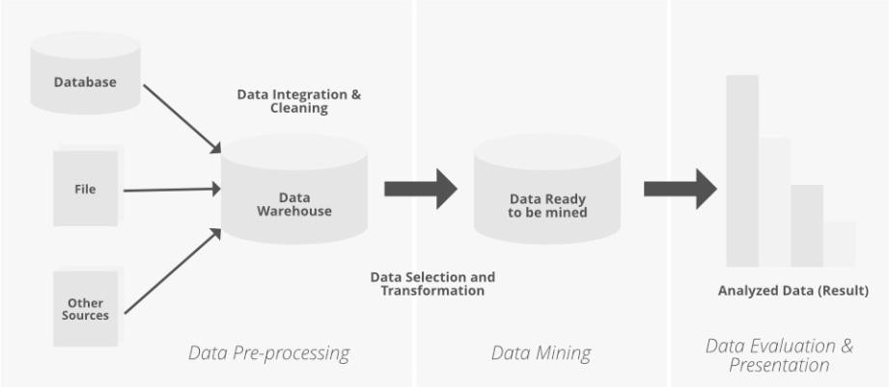

Data Mining Basic Diagram

#### Challenges and Limitations of Data Mining

One significant challenge in data mining is the issue of data quality and preprocessing. Often, real- world datasets are noisy, incomplete, or contain inconsistencies, which can significantly impact the effectiveness of data mining algorithms. Preprocessing tasks such as data cleaning, normalization, and feature selection are crucial for improving the quality of the data and ensuring accurate and reliable results. However, these tasks can be time-consuming and resource-intensive, especially for large and complex datasets. Moreover, even with careful preprocessing, there may still be underlying biases or limitations in the data that can affect the performance and generalization ability of the models. Therefore, addressing data quality and preprocessing challenges remains a critical aspect of successfuldata mining projects.

#### Applications of Data Mining

1. **Customer Relationship Management (CRM):** Data mining is a cornerstone in Customer Relationship Management (CRM), enabling businesses to delve deep into customer data for actionable insights. By scrutinizing diverse aspects such as demographics, purchase history, and behavioral patterns, companies can discern trends and preferences. This analysis facilitates the identification of high-value customers, prediction of churn rates, and crafting personalized marketing strategies. Leveraging data mining in CRM notonly enhances customer satisfaction but also fosters long-term loyalty and retention. Through targeted campaigns and tailored offerings, businesses can nurture stronger relationships with customers, ultimately driving growth and profitability.
2. **Fraud Detection:** Data mining techniques are instrumental in fraud detection systems, deployed across sectors like banking, insurance, and e-commerce. By scrutinizing transactional data and user behavior, algorithms can swiftly identify irregularities or suspicious trends that may signal fraudulent activity.

### Data Mining vs Data Warehousing

Data warehousing and data mining serve distinct but complementary purposes in data management. Data warehousing involves storing and organizing large volumes of data from various sources into a centralized repository, designed to support efficient querying and reporting for business intelligence. It focuses on the ETL (Extract, Transform, Load) process to ensure data consistency and accessibility.In contrast, data mining analyzes this stored data to discover patterns, trends, and relationships using algorithms and statistical methods. The primary goal of data mining is to transform raw data into actionable insights that inform business strategies and decision-making. While data warehousing emphasizes efficient storage and access, data mining focuses on extracting meaningful knowledge from the data. Together, they enable effective data management and strategic decision-making by leveraging stored data for in-depth analysis and discovery.

**REQUIREMENTS FOR THIS PROJECT:**

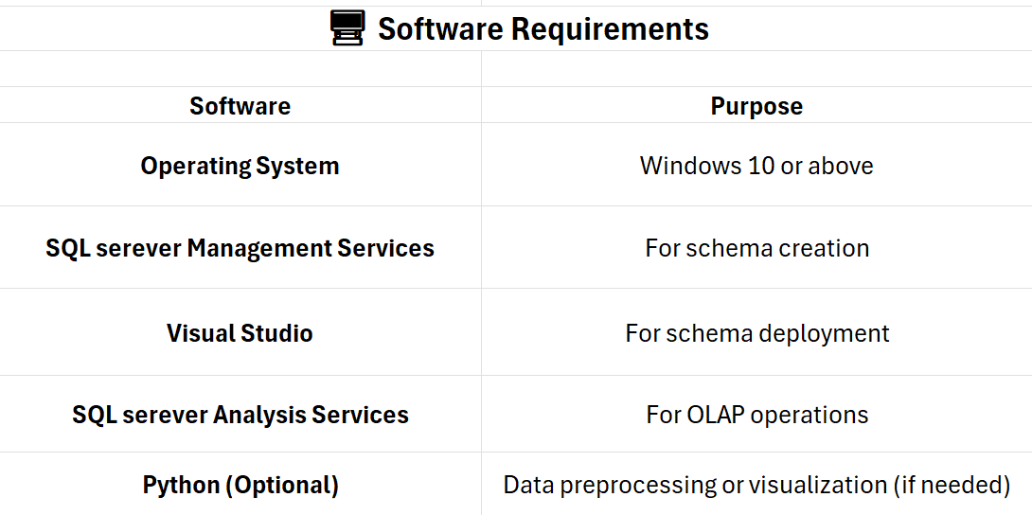

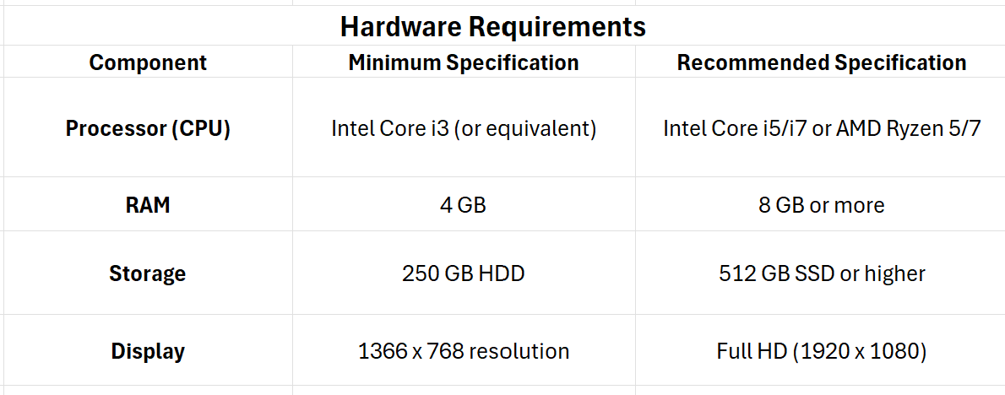

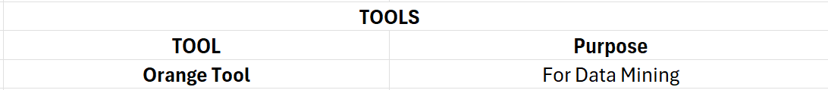

**CHAPTER 2:DATA MINING AND WARE HOUSING PROCESS ON**

**COLLECTED DATASET**

**2.1 Problem Statement:**

**Problem Statement: Online Shopping Analysis**

Analyzing customer purchasing behavior is crucial for improving marketing strategies, product recommendations, and sales optimization. Manual analysis of vast online shopping data is inefficient and inaccurate. This project leverages data mining techniques using the **Orange tool** to classify customers, identify shopping patterns, and predict trends. The insights will help businesses enhance **personalization, inventory management, and targeted marketing**, ensuring better decision-making and customer engagement.

**2.2 Methodology:**

The KDD process is performed in step by step from collection of data set to the classification and developing the prediction model. There are some intermediatory steps in which we created all three schemas

with the help of various tools like SSMS (SQL Server Management Services), Visual Studio and SSAS

(SQL Server Analysis Services). The process is explained in step by step below.

📝 Step 1:Dataset Collection and Exploration

│

▼

🛠 Step 2: Preprocessing of Data

│

▼

Step 3: Construction of OLAP Schemas

│

▼

🔍 Step 4: Visualization of Schemas

│

▼

Step 5: Build, Deploy and Process Multidimensional Cubes

& Create OLAP Queries

│

▼

📊 Step 6: Perform OLAP Operations

│

▼

🎨 Step 7: Visualize OLAP Results

│

▼

Step 8: Perform Data Mining

## Step 1: Dataset is collected Using Google Forms to anaylze Oneline

## shopping analysis

* Designed Google Form – with relevant questions (e.g., age, gender, viewing habits, OTT usage)

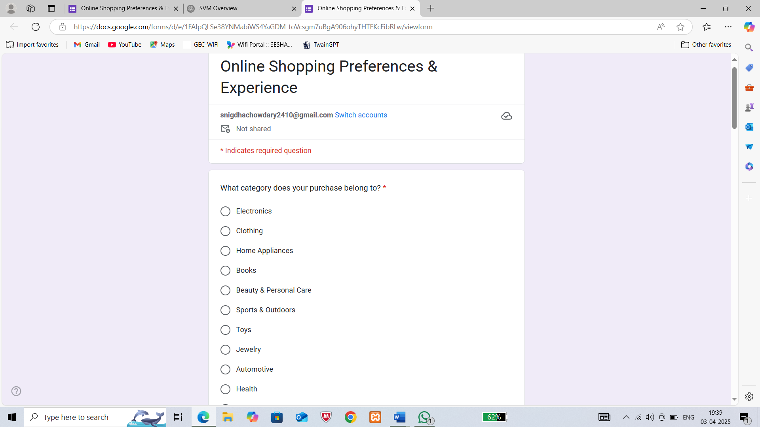 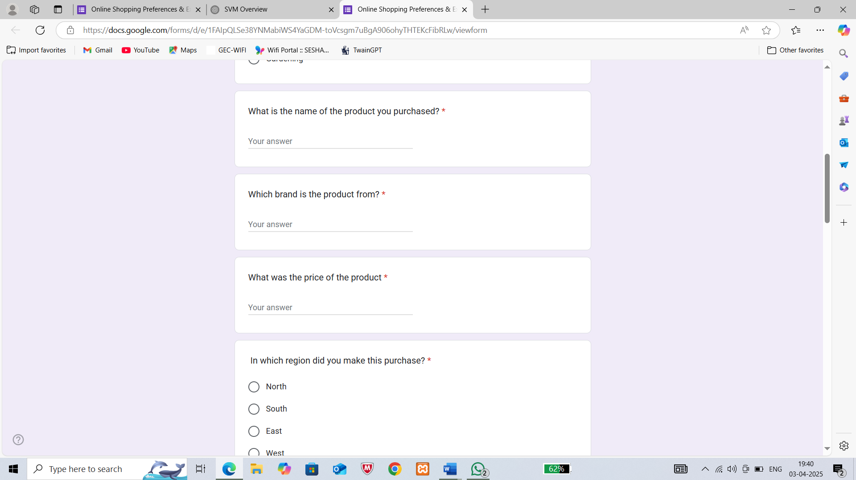 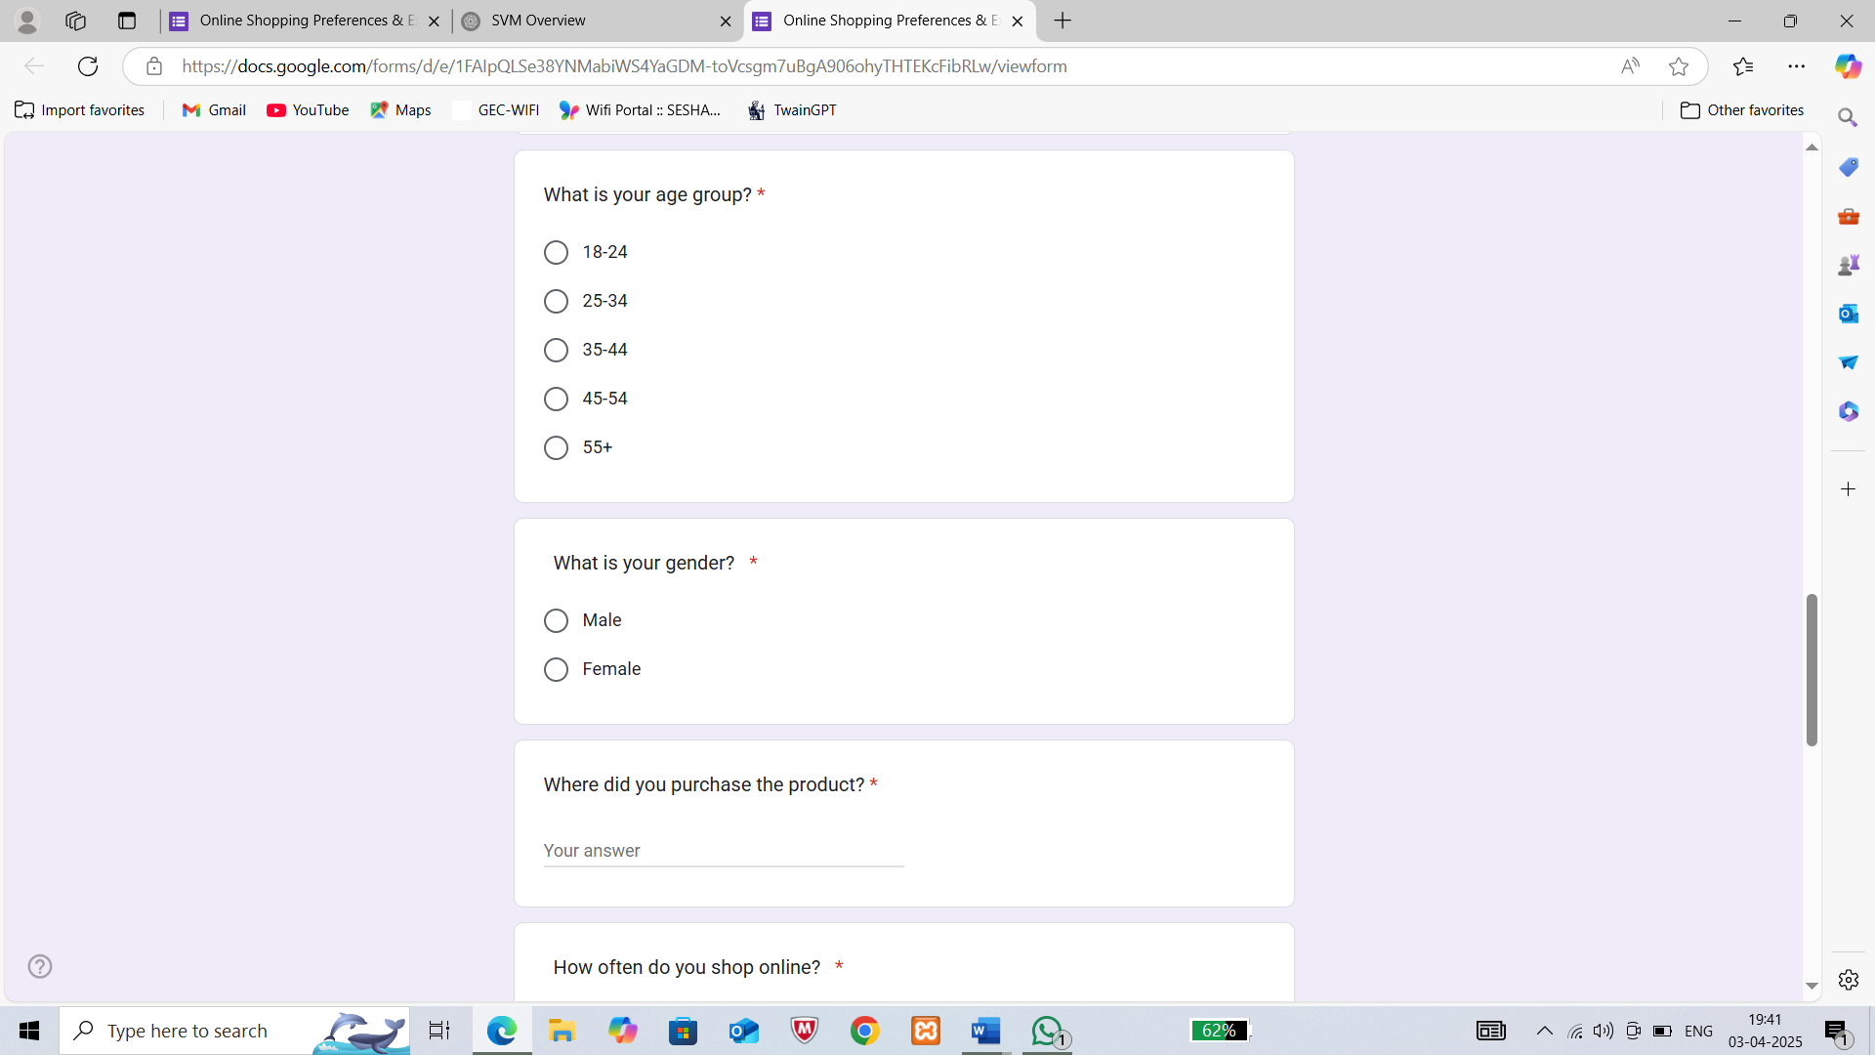

* Shared it with participants through email, social media, or targeted groups.

Link to the Google form: [Online Shopping Preferences & Experience](https://docs.google.com/forms/d/e/1FAIpQLSe38YNMabiWS4YaGDM-toVcsgm7uBgA906ohyTHTEKcFibRLw/viewform)

Collected Responses – Monitored responses and ensure enough data is gathered.

* Exported Data – Downloaded the responses as a CSV file for further processing.

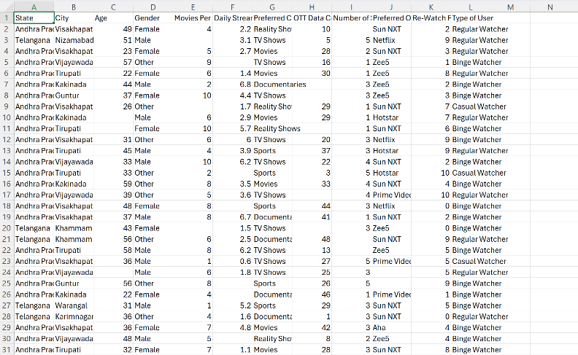

**List of fields used:**

* Shopping frequency
* Category name
* Product name
* Brand
* Price
* Region name
* Store name
* Age group
* Gender
* Purchase date
* Total spending
* Order quantity
* Order cost

**Step 2:** Data Preprocessing Using Orange Tool

(Select the best preprocessing technique using test and score)

* Load the Dataset – Import the collected CSV file into Orange.

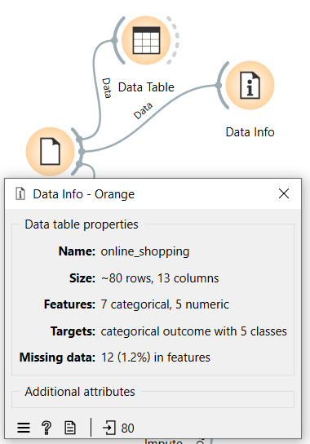

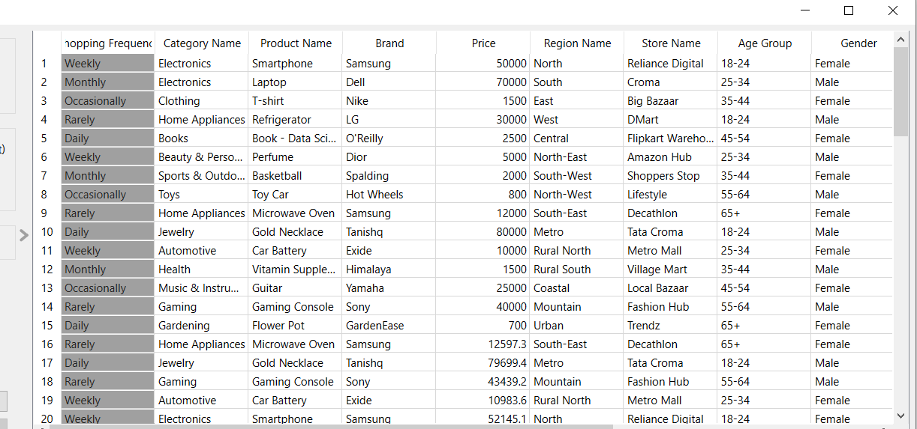

* Handle Missing Values – Used imputation techniques (mean, median, mode) to fill missing values.

**Before imputing**

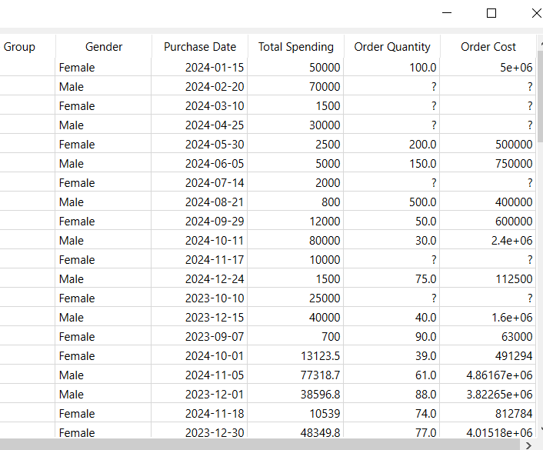

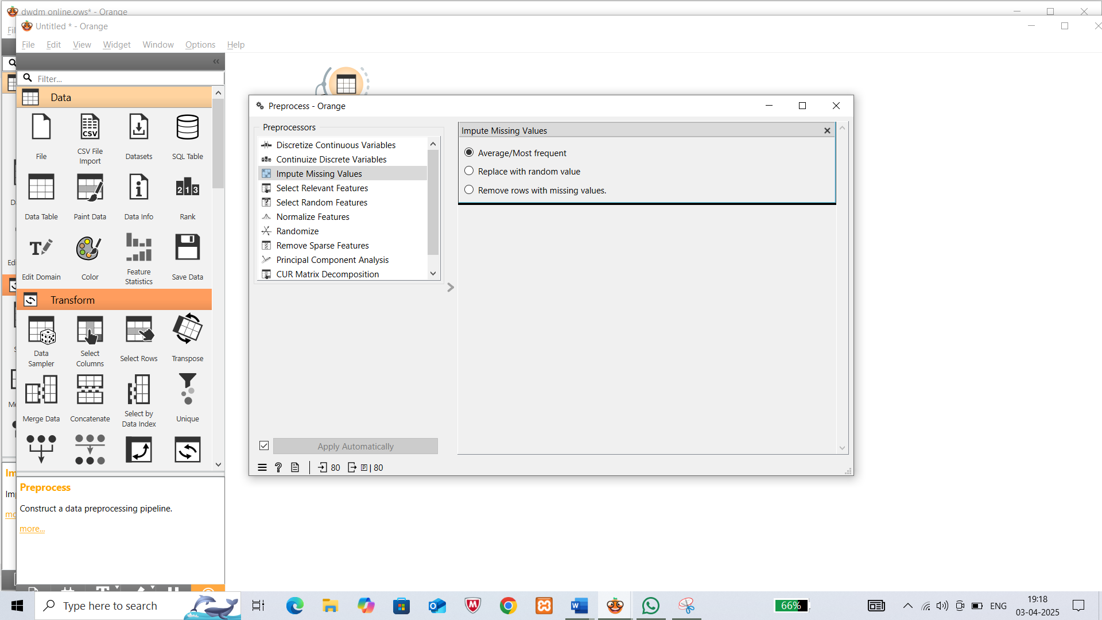

**AFTER IMPUTING**

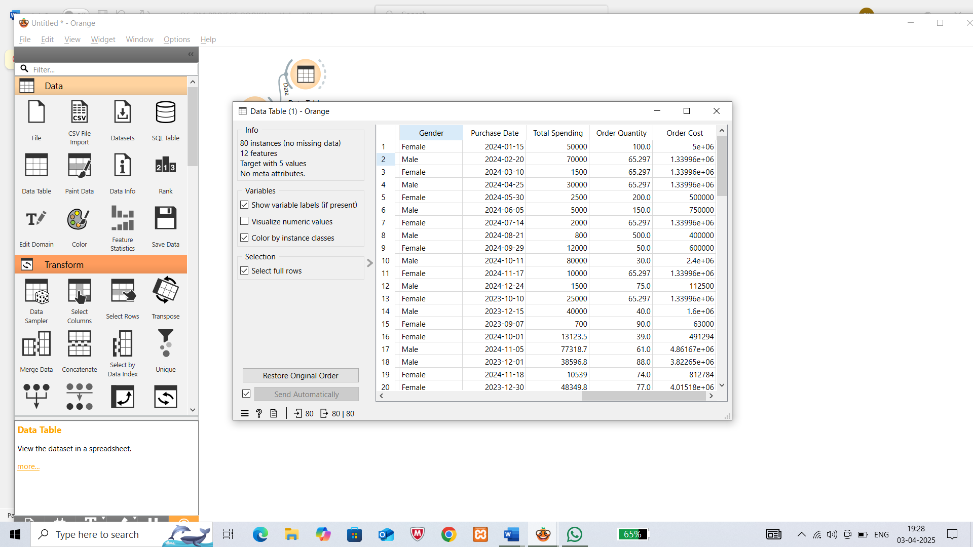

* Normalize & Transform Data – Normalized the numerical values using various techniques (Standardize, z-score, etc..)

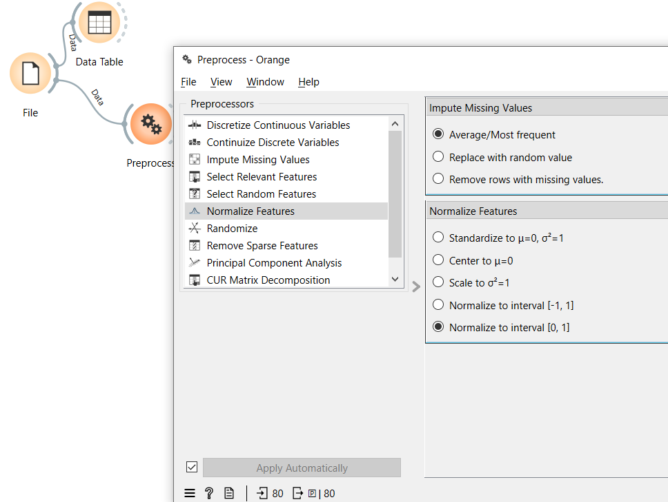

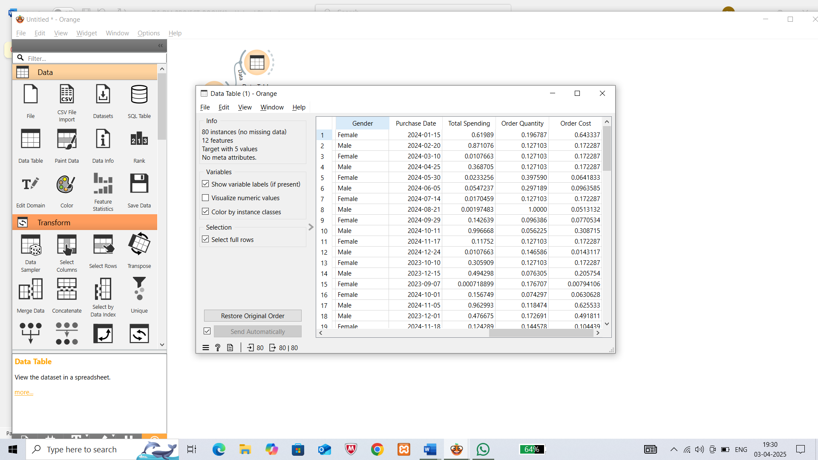

* Save Preprocessed Data – Export the cleaned dataset for further use.



Dataset after normalization

## Step 3: Schema Construction by Normalizing the Dataset (Using Database Engine)

## After Normalizing the following tables are identified:

## Dimension Tables:

## 1.Product:

## 

## 2.Store:

## 

## Customer:

## 

## Time:

## 

## Sub-Dimension tables/Extended tables:

## Region:

## 

## Product_category:

## Fact tables:

## Salesfact:

## 

## 2.Orderfact:

## 

## 

## Now Create a database “OTT” to insert all these tables.

## Generate SQL queries to create and insert data into all the tables in SQL Server Database Engine (SSMS).

## 

Database engine

## 

## SQL queries inserted for schema creation

**Step 4: Schema Visualization in Visual Studio**

* Create analysis service multidimensional project in Visual Studio.
* Create Data Sources & Data Source Views by Connected the database.
* View database diagrams for schemas and verify relationships between tables.
* Create Multidimensional cubes for schema.

These are the schemas

Star Schema:

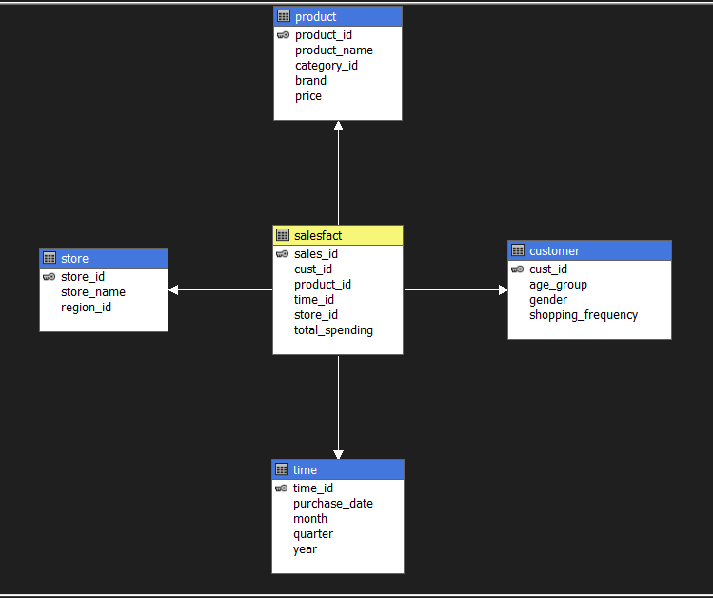

Star schema has one Fact table and Four Dimension tables.

* **Dimension tables :**

**1)Product –** product_id , product_name , category_id , brand , price

**2)Store –** store_id , store_name , region_id

**3)Customer –** cust_id , age_group , gender , shopping_frequency

**4) Time –** time_id , purchase_date , month , quarter , year

* **Fact table :**

**1)Salesfact –** sales_id , cust_id , product_id , time_id , store_id , total_spending,salesfact _count

**Snowflake Schema:**

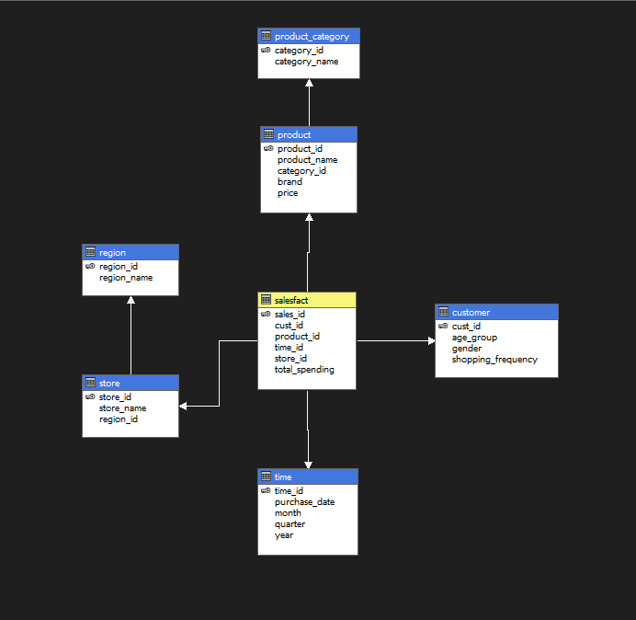

Snowflake schema has one Fact table, four Dimension tables and two Sub-Dimension tables.

* **Dimension tables :**

**1)Product –** product_id , product_name , category_id , brand , price

**2)Store –** store_id, store_name , region_id

**3)Customer –** cust_id , age_group, gender , shopping_frequency

**4) Time –** time_id , purchase_date , month , quarter , year

* **Extended tables :**

**1)Region –** region_id , region_name

**2)Product_category –** category_id , category_name

* **Fact table :**

**1)Salesfact –** sales_id , cust_id , product_id , time_id , store_id , total_spending,salesfact count

**Fact Constellation:**

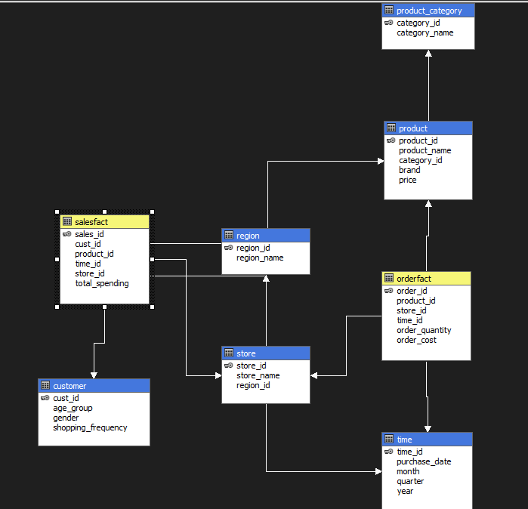

Fact Constellation has two Fact tables, four Dimension tables and two Sub-Dimension tables.

* **Dimension tables :**

**1)Product –** product_id , product_name , category_id , brand , price

**2)Store –** store_id, store_name , region_id

**3)Customer –** cust_id , age_group, gender , shopping_frequency

**4) Time –** time_id , purchase_date , month , quarter , year

* **Extended tables :**

**1)Region –** region_id , region_name

**2)Product_category –** category_id , category_name

* **Fact table :**

**1)Salesfact –** sales_id , cust_id , product_id , time_id , store_id , total_spending

**2)Orderfact** – order_id , product_id , store_id , time_id , order_quantity , order_cost

**Step 5:Build, Deploy and Process Multidimensional Cubes & Create OLAP Operations.**

Build deploy and process all the multi dimenensional cubes in visual studio and visualize them in SSAS server

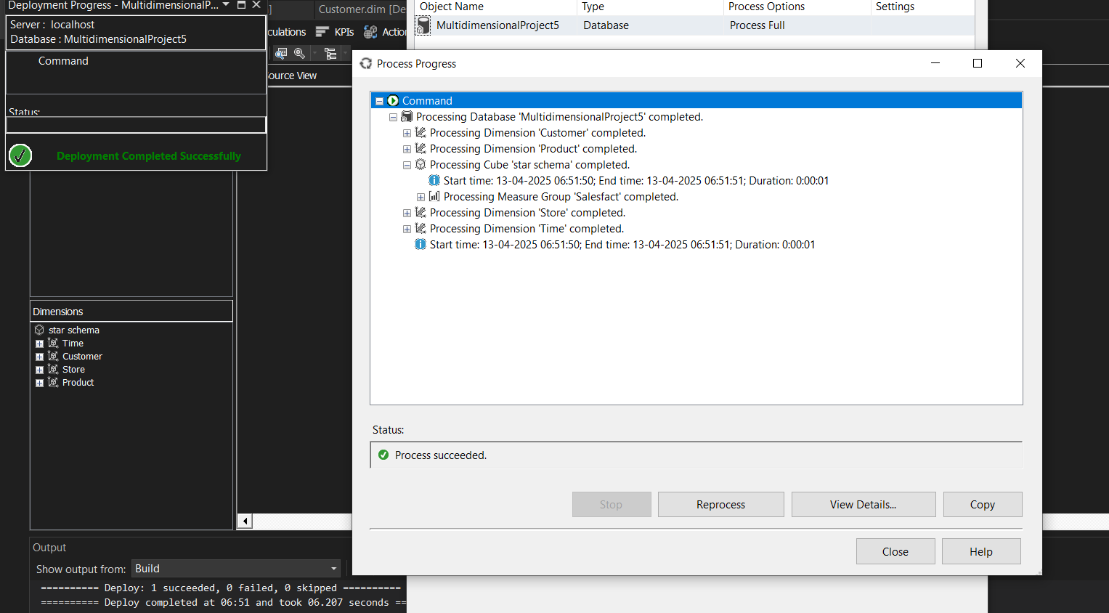

Build, Deploy and Processing Multidimensional Cubes

* Write MDX queries for Roll-Up, Drill-Down, Slice, Dice and Pivot operations in SSAS

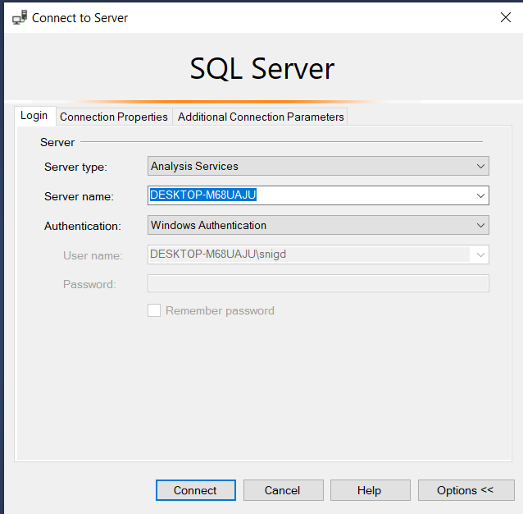

Analysis Services

* A **concept hierarchy** defines levels of abstraction in a dimension. It allows **attributes to be organized from low-level to high-level**, enabling data to be viewed at different levels of granularity.
* Concept hierarchies are **essential in data warehousing schemas** (like **star**, **snowflake**, and **fact constellation**) to support **OLAP operations** such as **roll-up**, **drill-down**, **slice**, and **dice** effectively.
* These are the concept hierarchies used to perform OLAP operations.

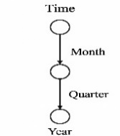

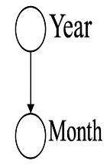

**Time Hierarchy Time Hierarchy**

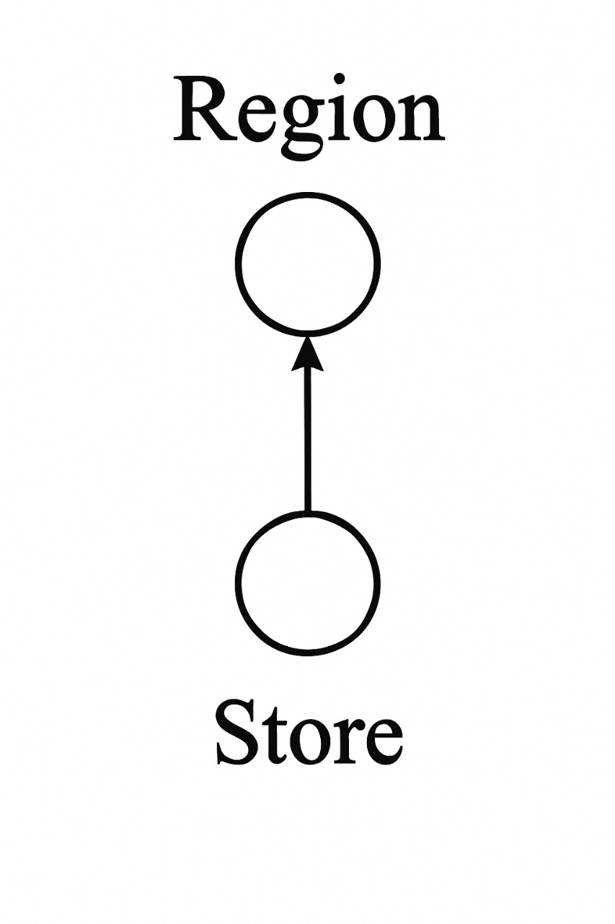  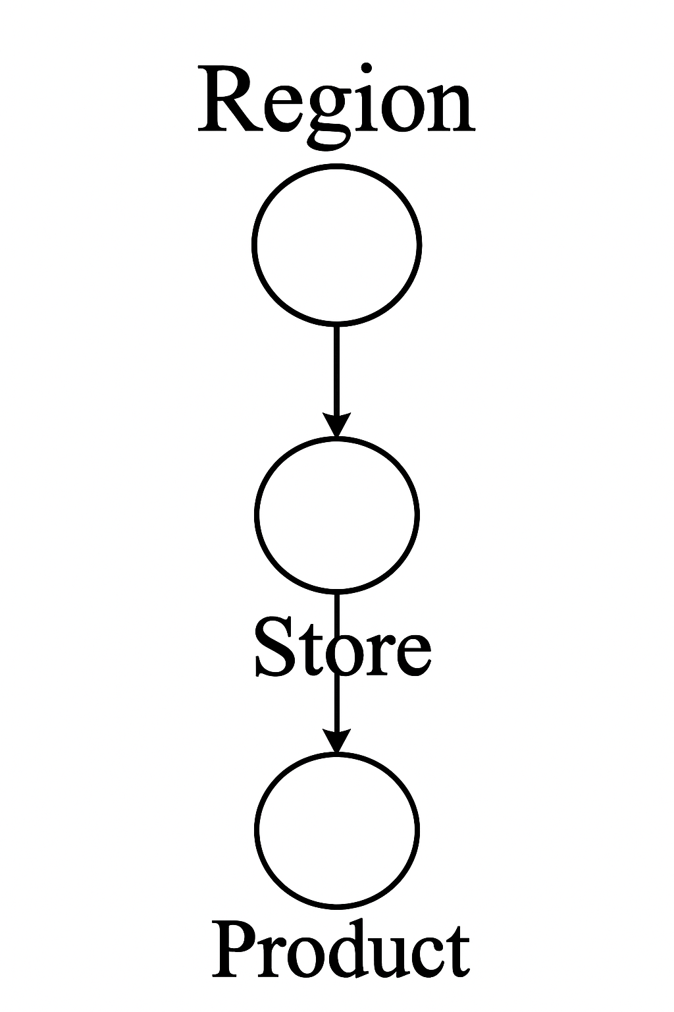

**Location Hierarchy Product Hierarchy**

**Step 6:** Perform OLAP Operations using MDX (Multidimensional Expressions) Queries.

## MDX Queries OLAP operations in star schema

## 

## 

## Roll up

**(A)** **What is the total spending and sales count for each combination of year, product, store, and customer age group?**

**Query:**

SELECT

{[Measures].[Total Spending], [Measures].[Salesfact Count]} ON COLUMNS,

NON EMPTY

CROSSJOIN(

[Time].[Year].Children,

CROSSJOIN(

[Product].[Product Name].Children,

CROSSJOIN(

[Store].[Store Name].Children,

[Customer].[Age Group].Children

)

)

)

ON ROWS

## OUTPUT:

## 

## Execution Time: 4 ms

**Sample Visualization:**

* First the OLAP results are used to create a excel sheet and then this sheet is loaded in the orange tool to perform visualization.

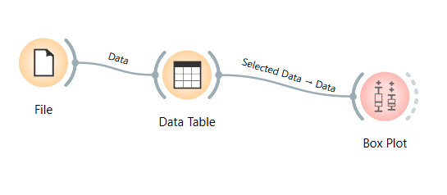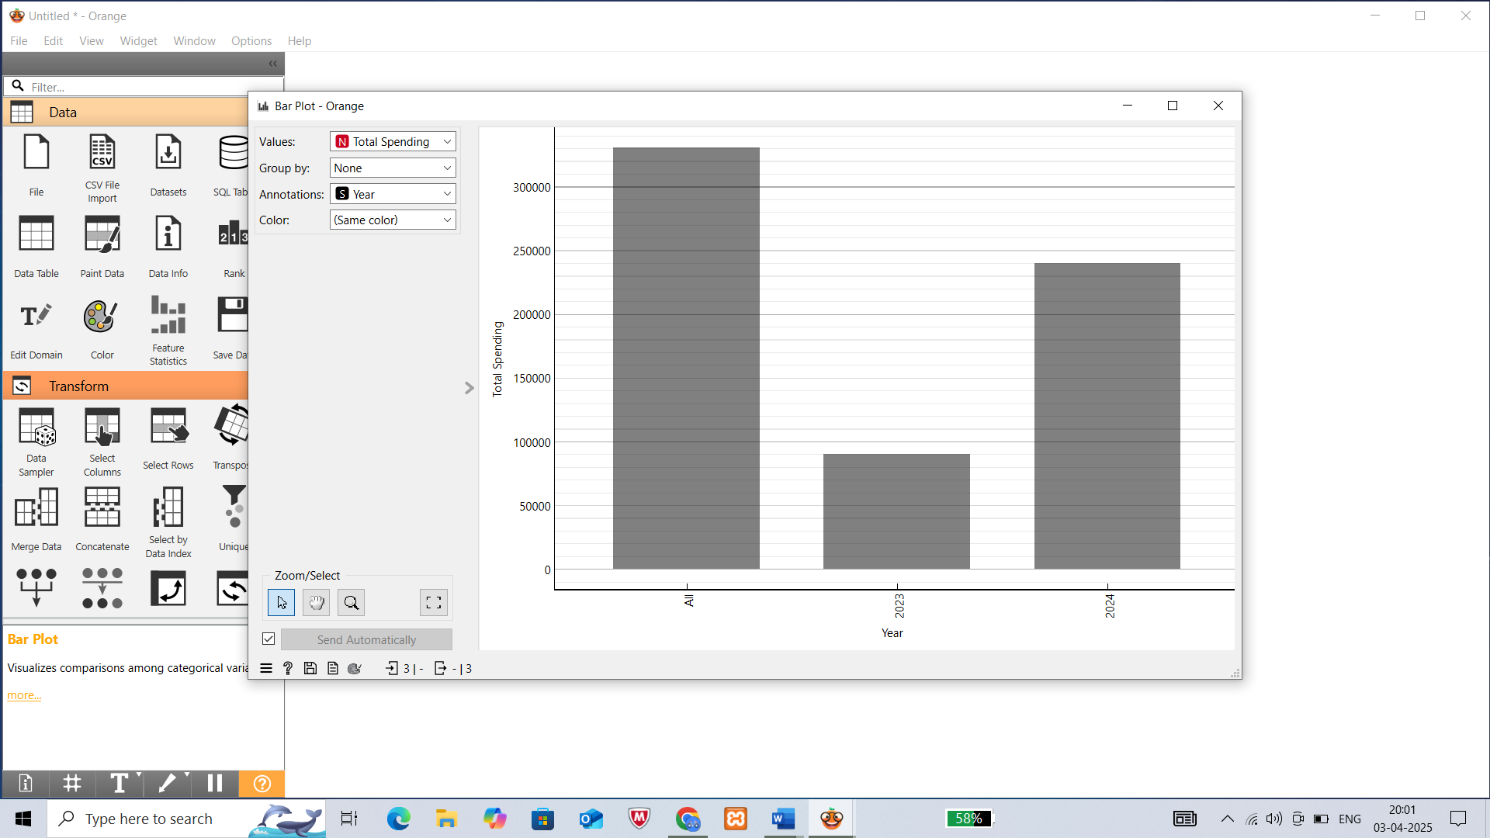

Figure: 1: Visualization Bar plot

The above fig 1 shows that total spending for the year 2023 and 2024

**Drill Down**

**(B)** **What is the total spending and sales count for each combination of month, product, store, and customer age group?**

**Query:**

SELECT

{[Measures].[Total Spending], [Measures].[Salesfact Count]} ON COLUMNS,

NON EMPTY

CROSSJOIN(

[Time].[Month].Children,

CROSSJOIN(

[Product].[Product Name].Children,

CROSSJOIN(

[Store].[Store Name].Children,

[Customer].[Age Group].Children

)

)

) ON ROWS

FROM [star schema]]

## Output:

## 

## Execution Time: 10 ms

**Sample Visualization:**

First the OLAP results are used to create a excel sheet and then this sheet is loaded in the orange tool to perform visualization

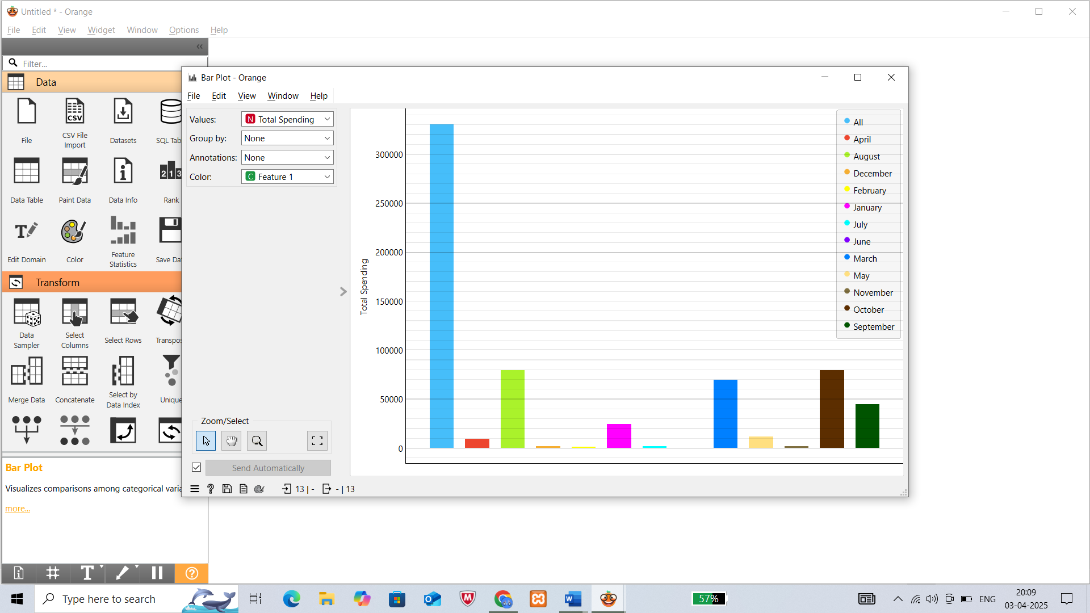

Figure: 2: Visualization Bar plot

## The above fig 2 bar plot shows that total spending for every month

## Slice:

**(C)** **What is the total spending for the year 2024?**

## Slice for year = “2024”

## Query:

SELECT

{[Measures].[Total Spending]} ON COLUMNS,

NONEMPTY(

[Customer].[Age Group].MEMBERS

) ON ROWS

FROM [star schema]

WHERE ([Time].[Year].[2024])

**Output:**

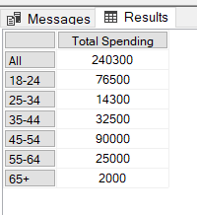

**Execution Time:** 4 ms

**Sample Visualization:**

* First the OLAP results are used to create a excel sheet and then this sheet is loaded in the orange tool to perform visualization.

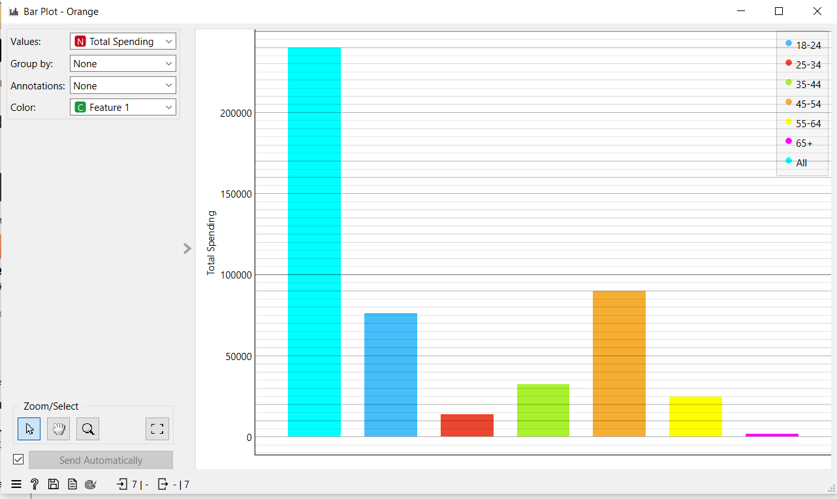

Figure: 3: Visualization Bar plot

The above fig 3 bar plot shows the total spending for every age-group

**Dice:**

**(D)** **What is the total spending for customers aged 25-34 in 2024?**

Dice for (Time.Year=”2024”) and (Customer=”Gender” ) and (Measures= “Total Spending”)

**Query:**

SELECT

{[Measures].[Total Spending]} ON COLUMNS,

{[Time].[Year].[2024]} * [Customer].[Gender].MEMBERS ON ROWS

FROM [star schema]

**Output:**

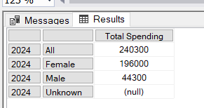

**Execution Time:** 4 ms

**Pivot:**

**(E)** **What is the total spending across different age groups?**

**Query:**

SELECT

{[Customer].[Age Group].Members} ON COLUMNS,

{[Time].[Year].Members} ON ROWS

FROM [star schema]

WHERE [Measures].[Total Spending]

**Output:**

SELECT

{[Customer].[Age Group].Members} ON COLUMNS,

{[Time].[Year].Members} ON ROWS

FROM [star schema]

WHERE [Measures].[Total Spending]

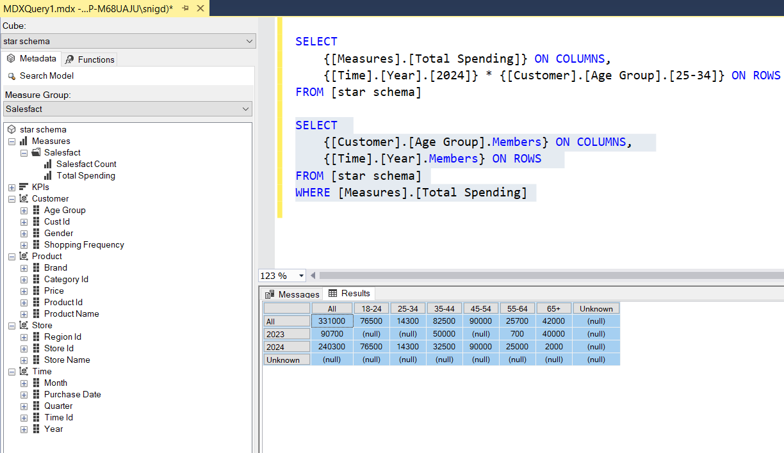

**Execution Time:** 4 ms

## MDX Queries for OLAP operations in Snow Flake Schema:

## 

## Roll-up:

1. **"What is the total spending and sales count grouped by store name, region name, product name, category ID, customer age group, year, and quarter?"**

**Query:**

SELECT

{[Measures].[Total Spending], [Measures].[salesfact count]} ON COLUMNS,

NON EMPTY

CROSSJOIN(

[Store].[Store Name].[Store Name].Members,

CROSSJOIN(

[Store].[Region Name].[Region Name].Members,

CROSSJOIN(

[Product].[Product Name].[Product Name].Members,

CROSSJOIN(

[Product].[Category ID].[Category ID].Members,

CROSSJOIN(

[Customer].[Age Group].[Age Group].Members,

CROSSJOIN(

[Time].[Year].[Year].Members,

[Time].[Quarter].[Quarter].Members

)

)

)

)

)

) ON ROWS

FROM [snow flake schema]

**Output:**

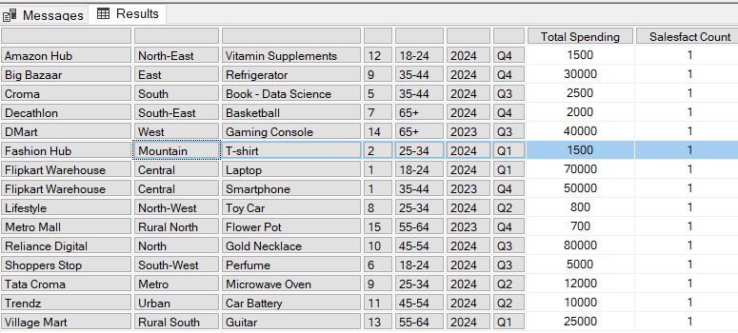

**Execution Time:** 3 ms

**Sample Visualization:**

* Since this OLAP output has most of the Null values we filled the missing values manually for better visualization. Visualization is done using the orange tool.
* First the OLAP results are used to create a excel sheet and then this sheet is loaded in the orange tool to perform visualization.

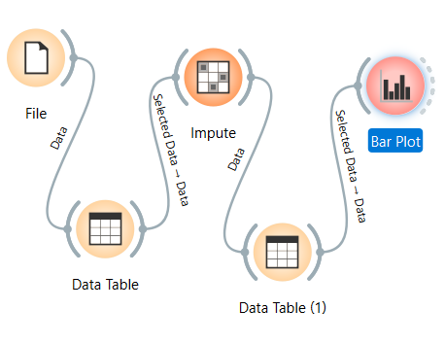

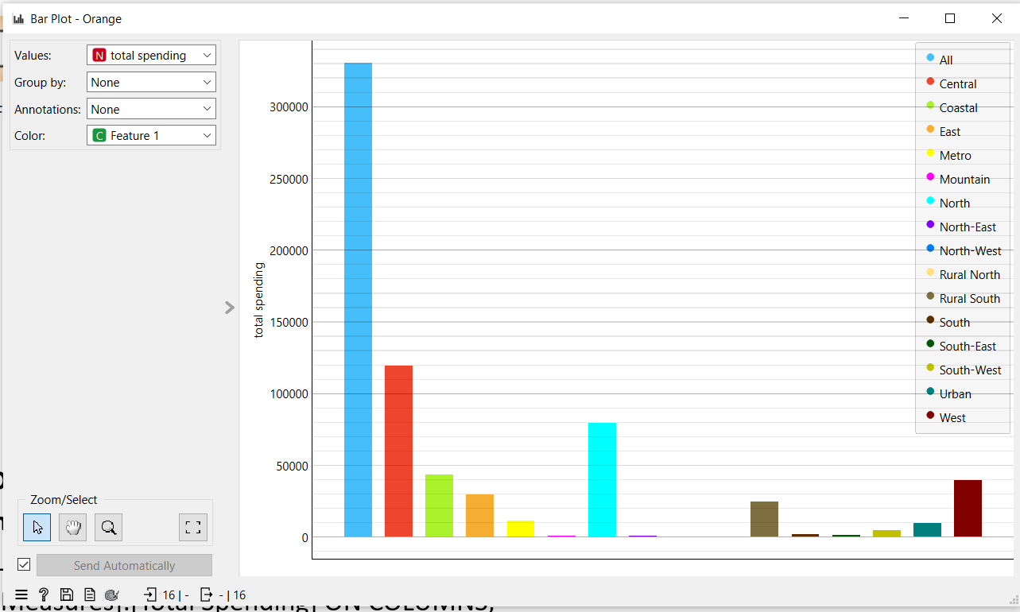

Figure: 4: Visualization Bar plot

The above fig 4 bar plot shows total spending on every region

**Drill Down:**

**(B)** **What is the total spending store name, customer age group, year, and quarter?**

from Region to Store Level

**Query:**

SELECT

[Measures].[Total Spending] ON COLUMNS,

NON EMPTY

CROSSJOIN(

[Store].[Store Name].[Store Name].Members,

CROSSJOIN(

[Customer].[Age Group].[Age Group].Members,

CROSSJOIN(

[Time].[Year].[Year].Members,

[Time].[Month].[Month].Members

)

)

)

ON ROWS

FROM [snow flake schema]

**Output:**

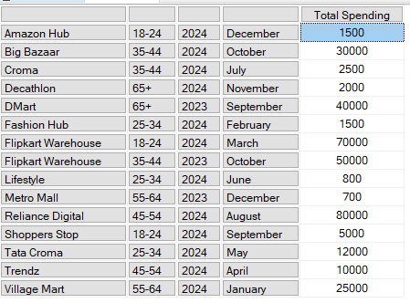

**Execution Time:** 5 ms

**Slice:**

**(C)** **What is the total spending for October?**

Slice for Month = ”October”

**Query:**

SELECT

[Measures].[Total Spending] ON COLUMNS

FROM [snow flake schema]

WHERE ([Time].[Month].[October])

**Output:**

## 

**Execution Time:** 1 ms

**Dice:**

**(D)** **What is the total spending on electronics in 2024?**

## Query:

SELECT

NON EMPTY [Store].[Region Name].MEMBERS ON ROWS,

NON EMPTY [Time].[Year].[2024] ON COLUMNS

FROM [snow flake schema]

WHERE ([Measures].[Total Spending], [Product].[Category Name].[Electronics])

**Output:**

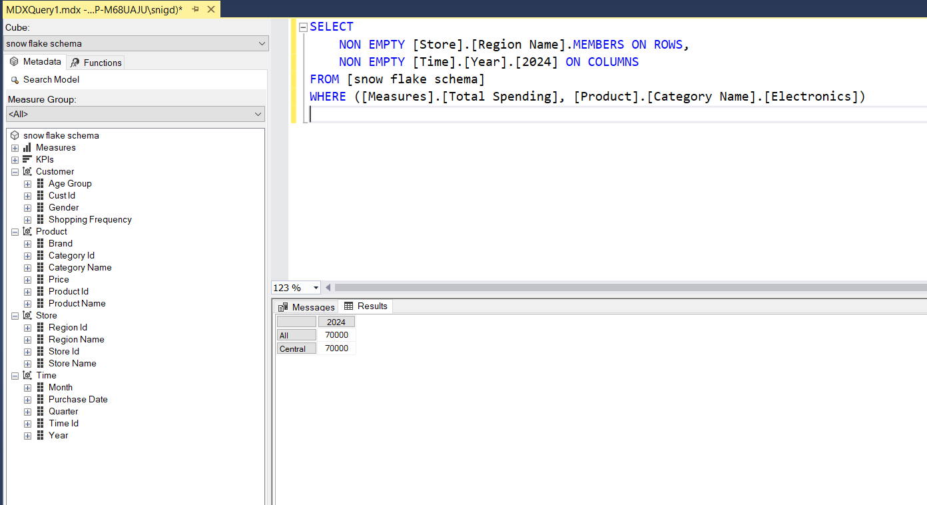

**Execution Time:** 1 ms

**Pivot:**

**(E)** **How does total spending vary across different stores?**

**Query:**

SELECT

[Time].[Year].MEMBERS ON COLUMNS,

[Store].[Store Name].MEMBERS ON ROWS

FROM [snow flake schema]

WHERE ([Measures].[Total Spending])

**Output:**

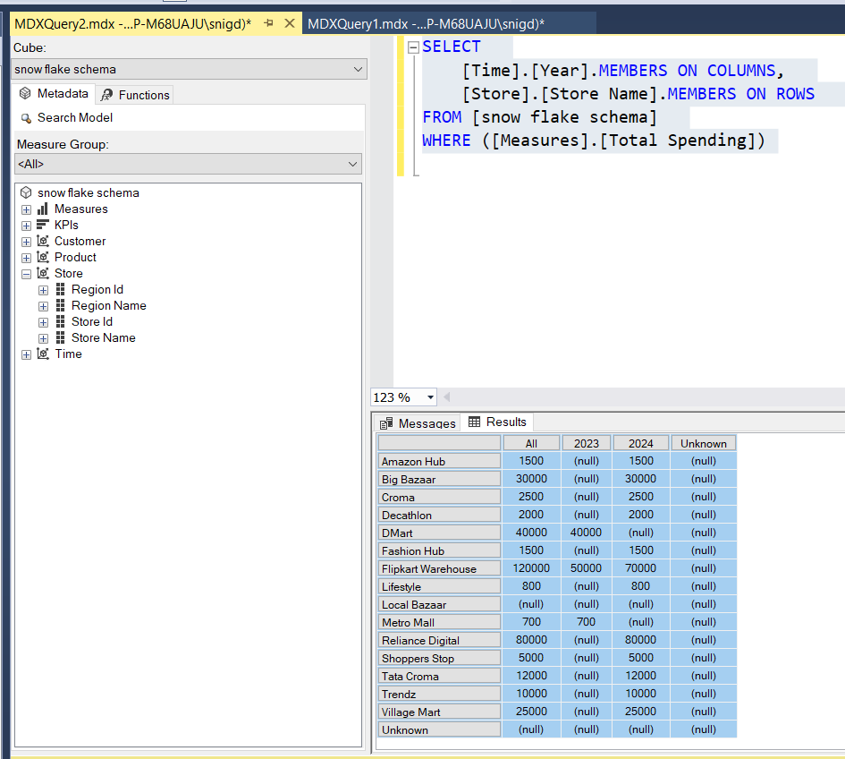

**Execution Time:** 3 ms

**Sample Visualization:**

* Since this OLAP output has most of the Null values we filled the missing values manually for better visualization. Visualization is done using the orange tool.
* First the OLAP results are used to create a excel sheet and then this sheet is loaded in the orange tool to perform visualization.

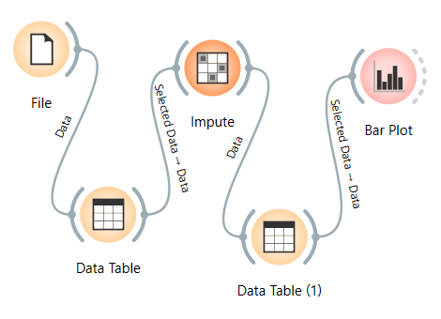

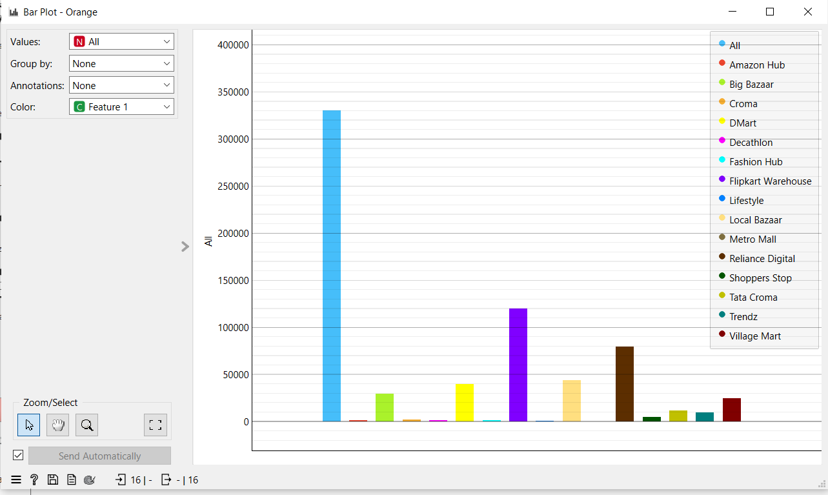

Figure: 5: Visualization Bar plot

The above fig 5 bar plot shows total spending for every store

**MDX Queries for OLAP operations in Fact Constellation:**



## Roll-up:

**(A)What is the total spending in different regions?**

Query:

SELECT

[Measures].[Total Spending] ON COLUMNS,

[Store].[Region Name].MEMBERS ON ROWS

FROM [fact constellation schema]

**Output:**

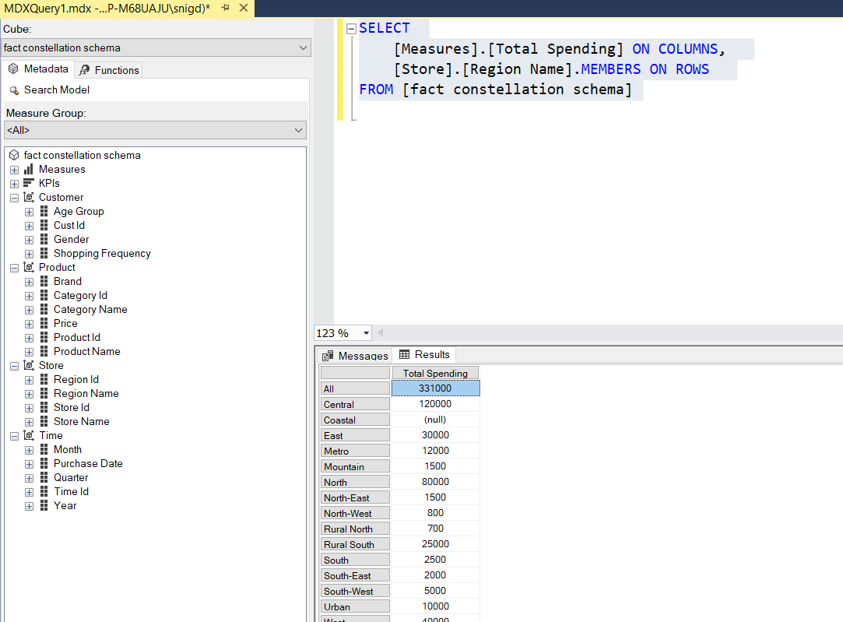

**Execution Time:** 5 ms

**Drill Down:**

**(B) What is the total spending for each product?**

**Query:**

SELECT

[Measures].[Total Spending] ON COLUMNS,

[Product].[Product Name].MEMBERS ON ROWS

FROM [fact constellation schema]

**Output:**

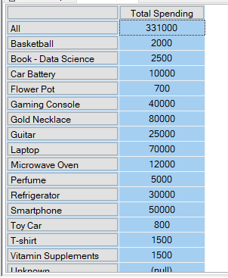

**Execution Time:** 5 ms

**Slice:**

**(C) What is the total spending for the year 2023?**

Slice for Year = ”2023”

**Query:**

SELECT

[Measures].[Total Spending] ON COLUMNS

FROM [fact constellation schema]

WHERE ([Time].[Year].[2023])

]

**Output:**

## 

**Execution Time:** 1 ms

**Dice:**

**(D)** **Which regions contribute to clothing spending in 2024?**

**Query:**

SELECT

[Measures].[Total Spending] ON COLUMNS,

[Store].[Region Name].MEMBERS ON ROWS

FROM [fact constellation schema]

WHERE ([Time].[Year].[2024], [Product].[Category Name].[Clothing])

**Output:**

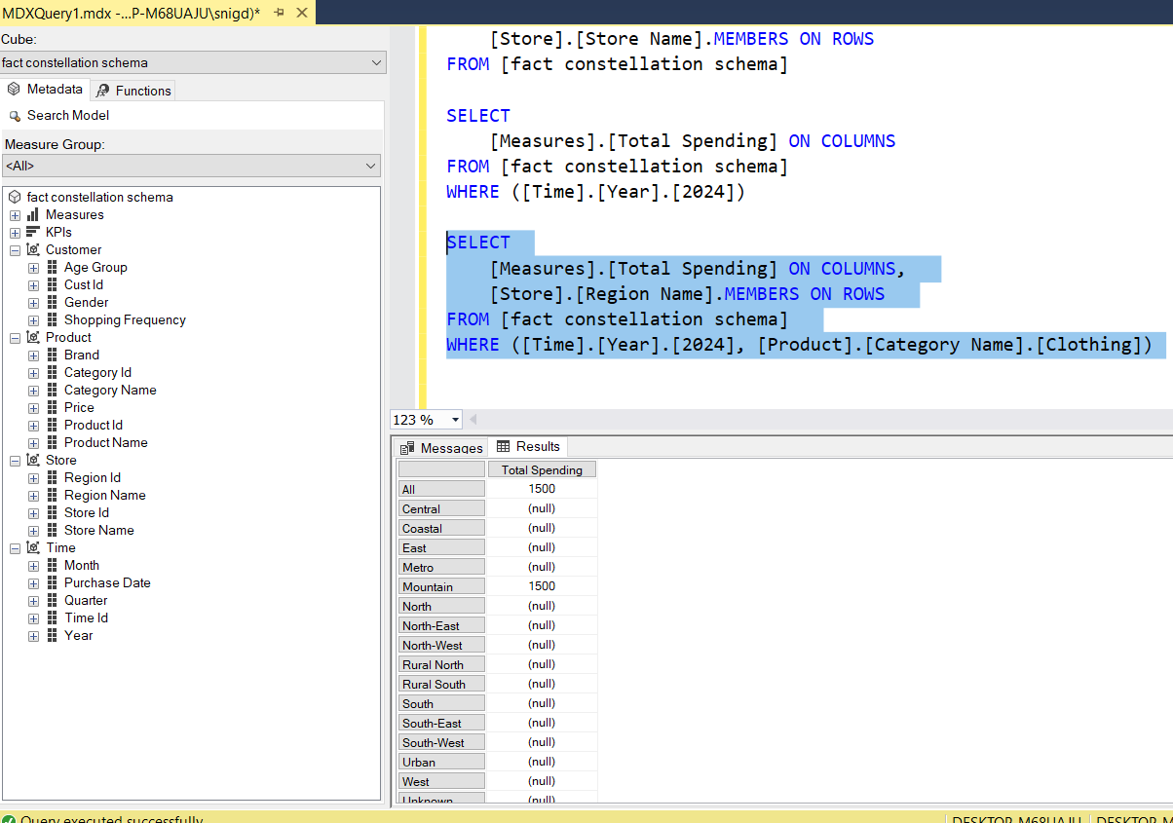

**Execution Time:** 2 ms

**Pivot:**

**(E) How does total spending vary across different regions and years?**

**Query:**

SELECT

[Time].[Year].MEMBERS ON COLUMNS,

[Store].[Region Name].MEMBERS ON ROWS

FROM [fact constellation schema]

WHERE ([Measures].[Total Spending])

**Output:**

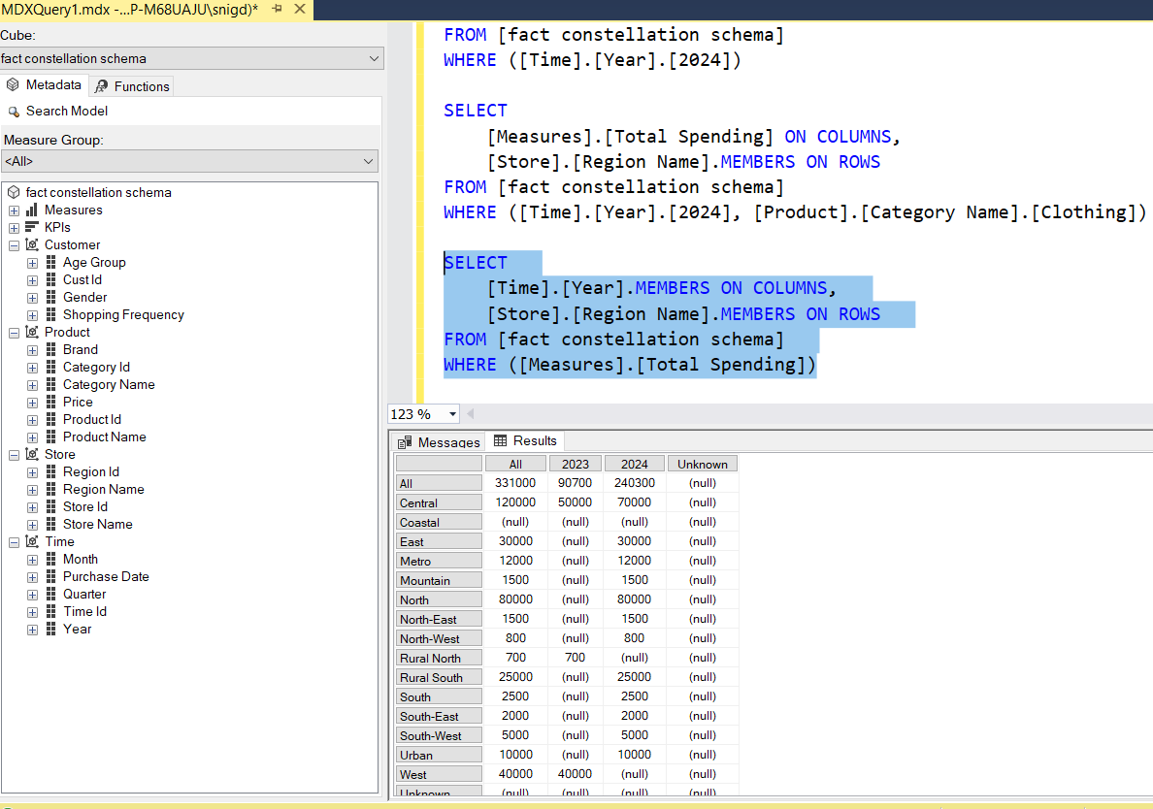

**Execution Time:** 3 ms

## Step 7: Perform Data Mining on the Dataset

One can perform any data mining technique like Classification, Regression, Clustering and Association rule Mining. According to my data set we choose to perform Classification on data set we want to Classify the whether the person is shopping occasionally or weekly or monthly or rarely or daily. We mentioned this also in our problem Statement.

* The Most suitable model for my preprocessed dataset is Classification. The target class has five values in my classification model.

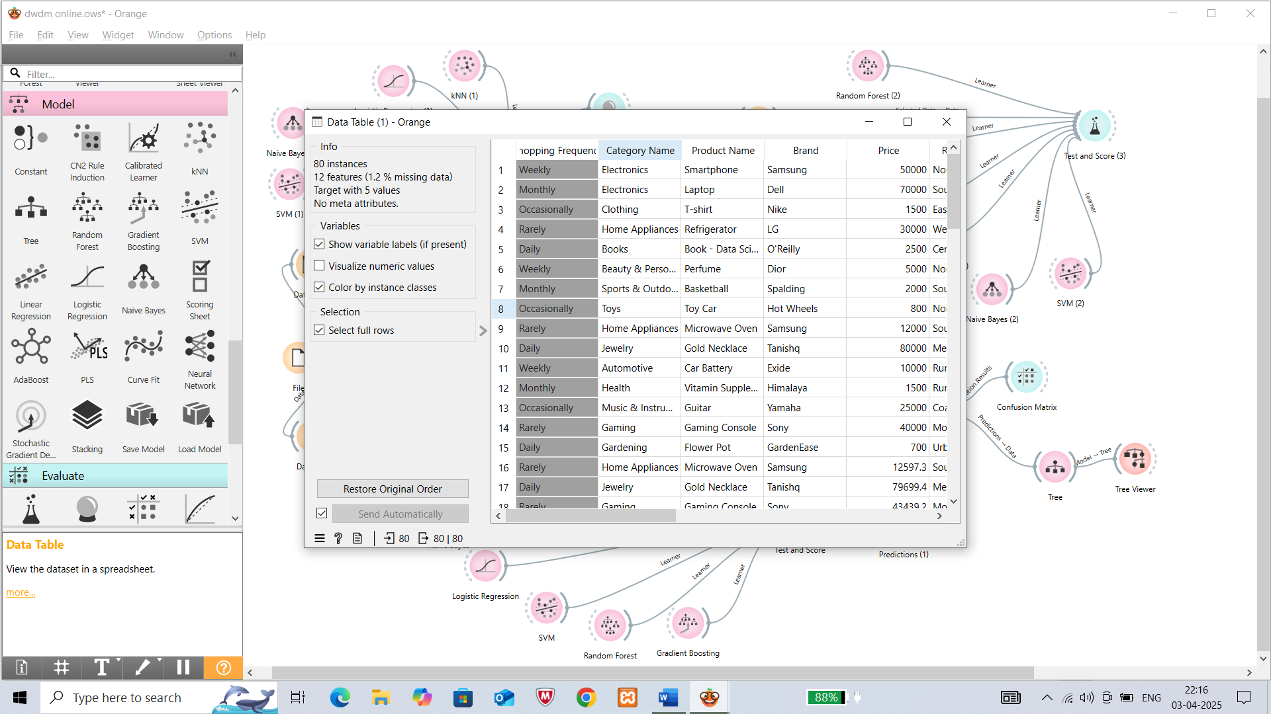

* Check the Classification (Classification Methodology is explained further in Part-B in detail) accuracy for the various classification models using the test and score widget.
* Use metrics like accuracy, precision, recall, and F1-score to select the best model.

Without preprocessing With Preprocessing

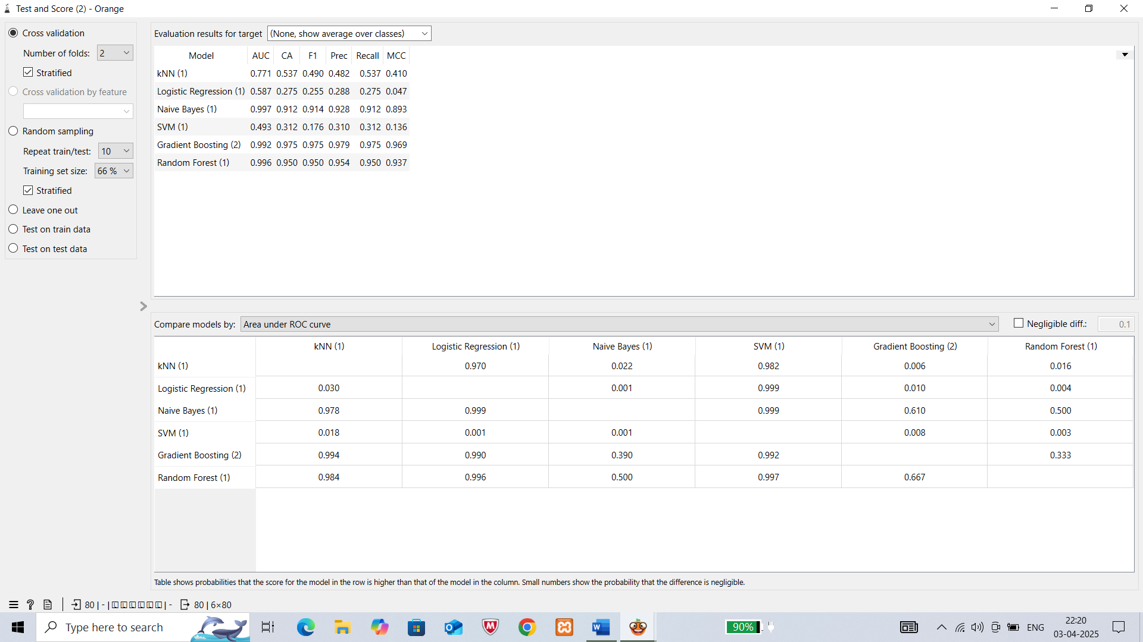 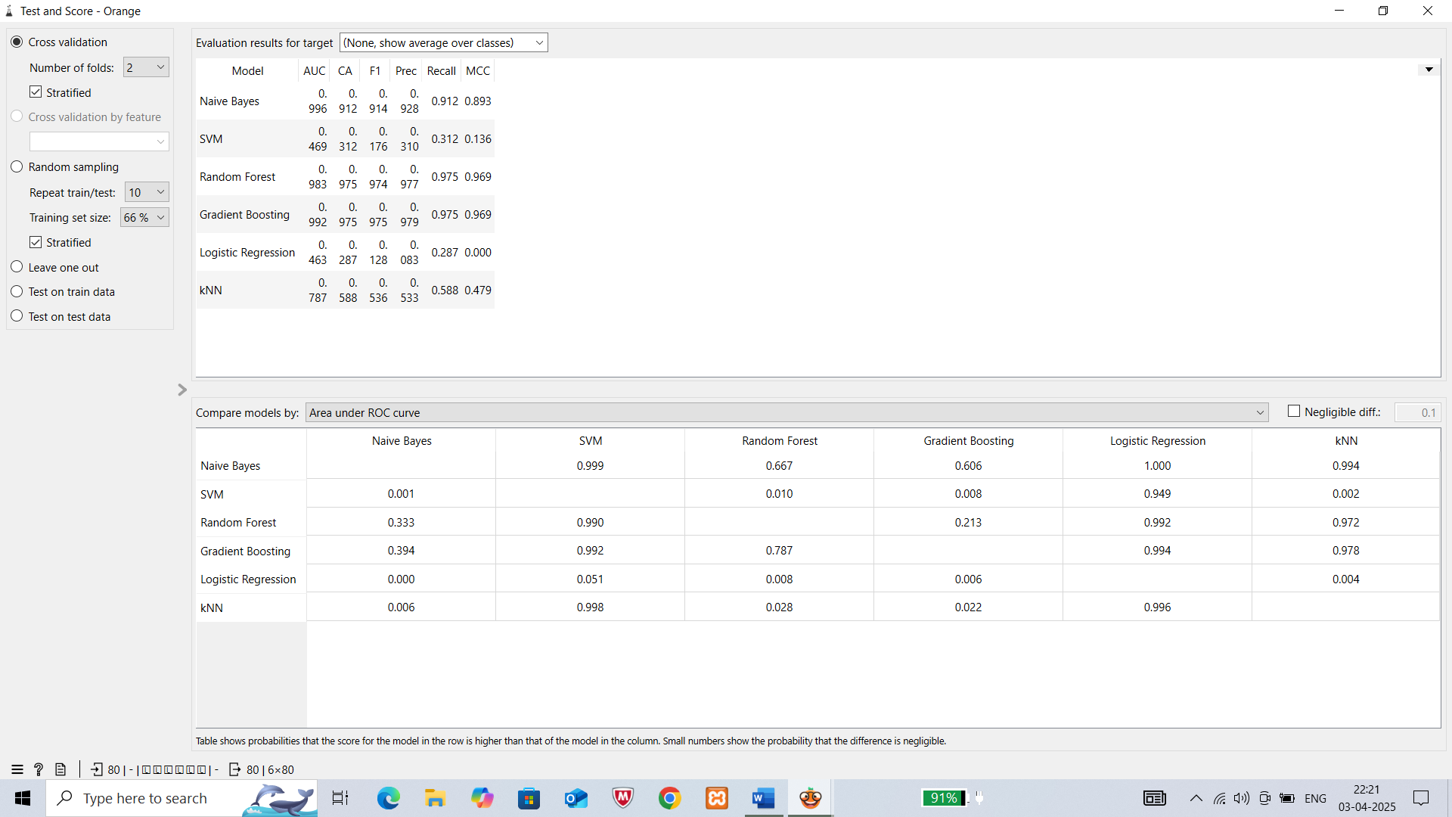

By all the observations,we decided that Gradient Boosting model is best my for my datset for classification

**EVALUATION METRICS:**

Confusion Matrix(Without preprocessing) Confusion (with preprocessing)

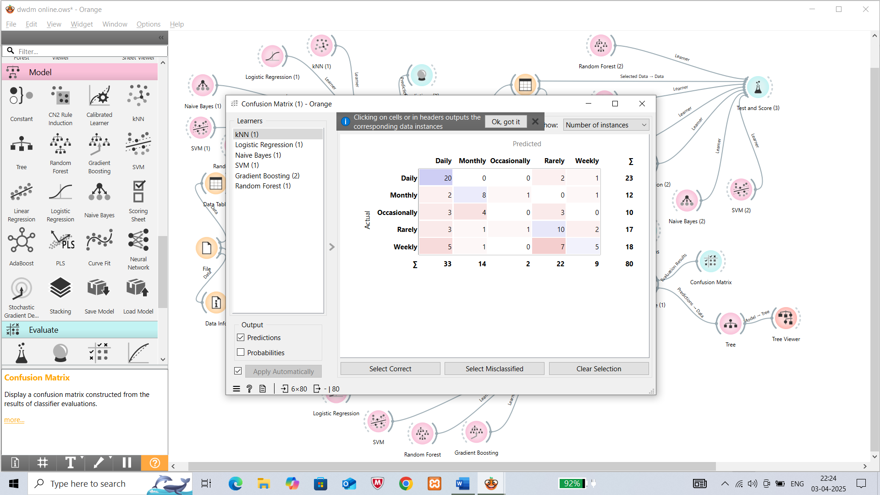 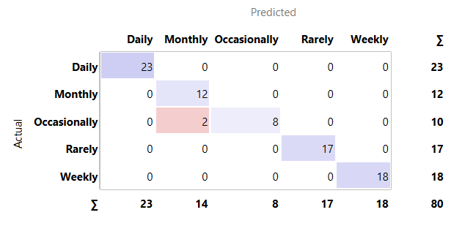

* Here the Workflow Model in Orange Tool for my classification.

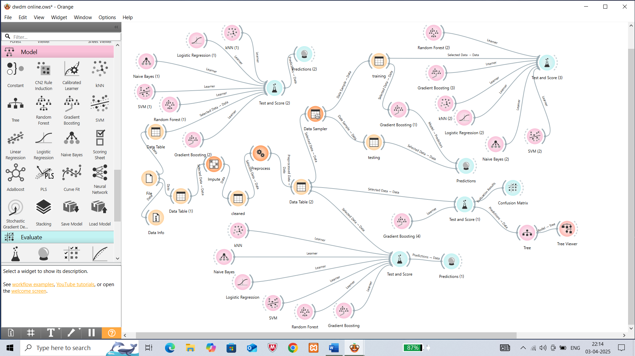

**CHAPTER 3: EXPERIMENTAL ANALYSIS**

* Study Classifier Accuracy

Use Test & Score widget to view the classifier output, including accuracy, precision, recall, F-measure, and other metrics.

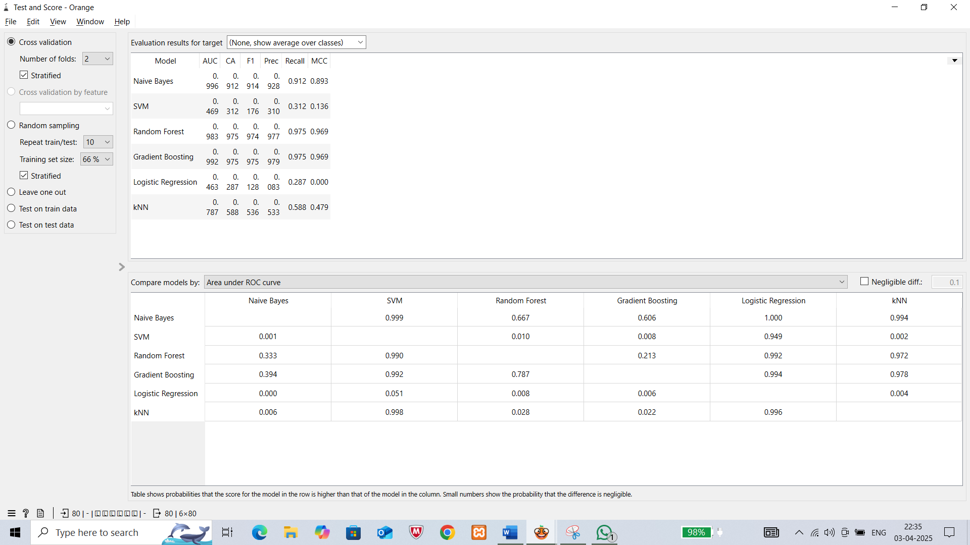

Figure 3: Test & Score measurements

Figure 3 shows readings of various evaluation metrics like AUC, CA, F1, Frequency, etc…

* Evaluate Model Performance

Observe the confusion matrix and derive metrics such as Accuracy, F- measure, True Positive

Rate (TPR), False Positive Rate (FPR), Precision, and Recall.

Apply cross-validation strategy with various fold levels in the Test & Score widget to

compare accuracy results.

* This is the confusion matrix for the best classification model (Here in our case best model based on CA is Classification tree)

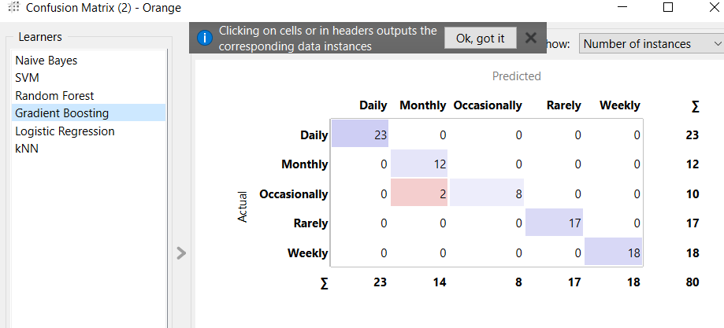

Figure 4: Confusion matrix of Gradient Boosting

Figure 4 shows that the classification performance of a decision tree model for Online Shopping Analysis user behavior correctly classifies **Daily (23/23)** ,**Monthly(12/12),Occasionally(6/8),Rarely (17/17),Weekly(18/18)**

**BARPLOT ANALYSIS**

**Without preprocessing**

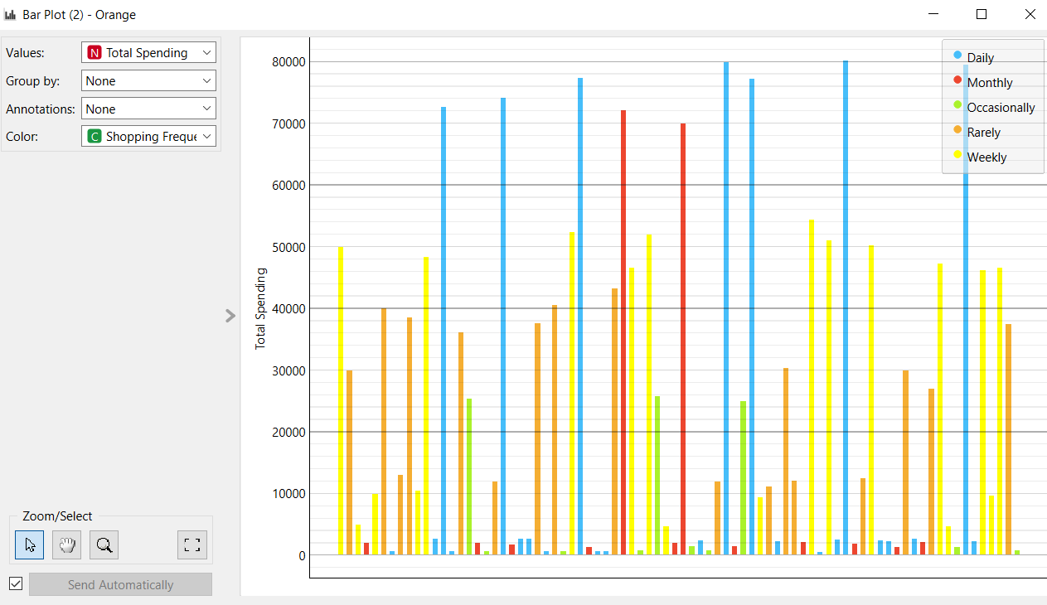

This Bar Plot shows that the

**Y-Axis:** Represents "Total Spending" (numeric values).

**X-Axis:** Represents different data points (individuals or categories).

**Color Coding:** Indicates **Shopping Frequency**, as shown in the legend on the right:

* **Blue** → Daily
* **Red** → Monthly
* **Green** → Occasionally
* **Brown** → Rarely
* **Yellow** → Weekly
* People who shop **daily (blue bars)** tend to have high spending, often reaching **80,000+**.
* **Monthly shoppers (red bars)** also have significant spending but are less frequent.
* **Weekly (yellow)** and **rare (brown)** shoppers have varied spending patterns.
* **Occasional shoppers (green bars)** seem to have relatively lower spending.

**With preprocessing**

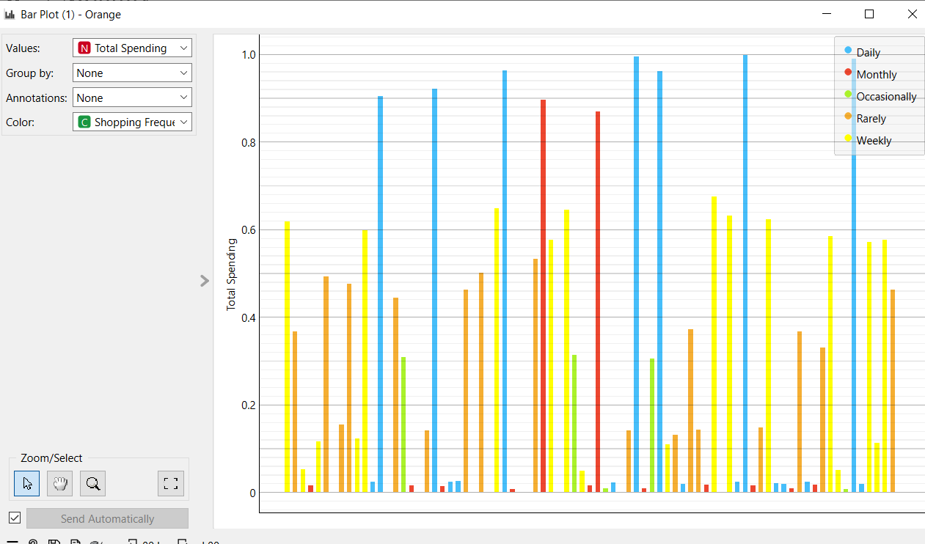

* Each point on the scatter plot represents a data point for Shoppingg frequency for a particular Region

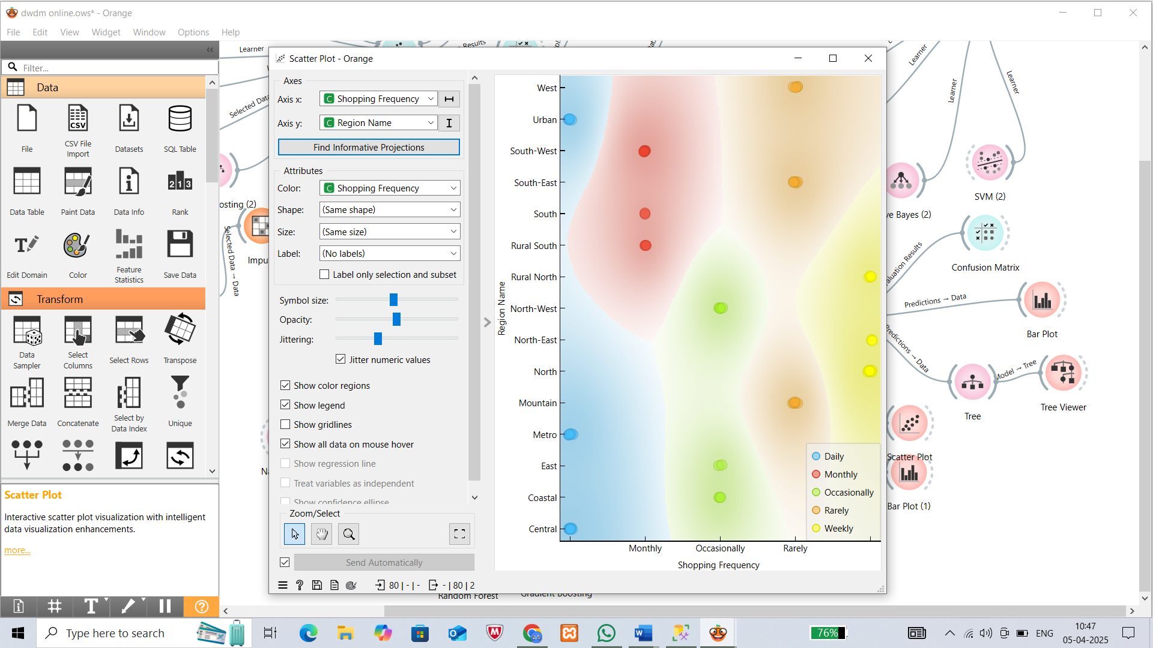

**Prediction model:**

Now based on the classifier accuracy we developed a predicion model by spliting the dataset into training dataset and testing dataset.

The training dataset is directly given from the preprocessor and test data is given externally to the prediction model.

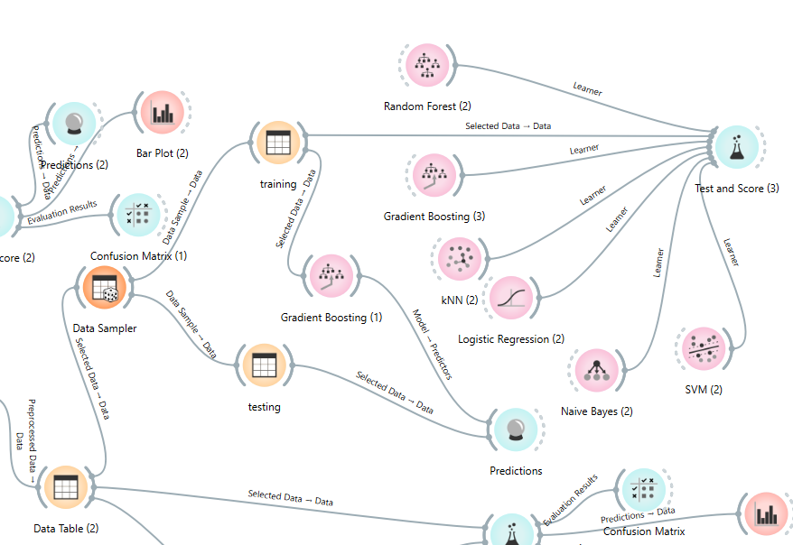

* The predictions that are given by our classification tree prediction model is The prediction model also gives error rate and accuracy.
* It gives maximum zero errors

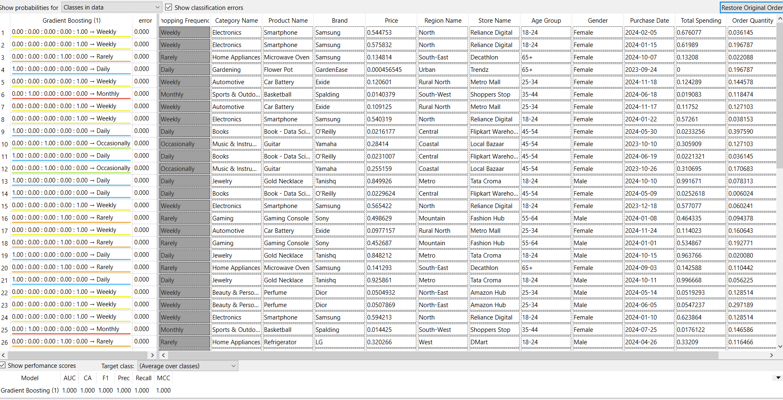

* Now coming to the Visualization of the model we selected a tree viewer for our classification tree model.

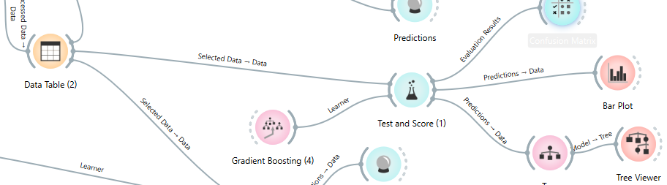

* The classification tree for the Classification model is as follows

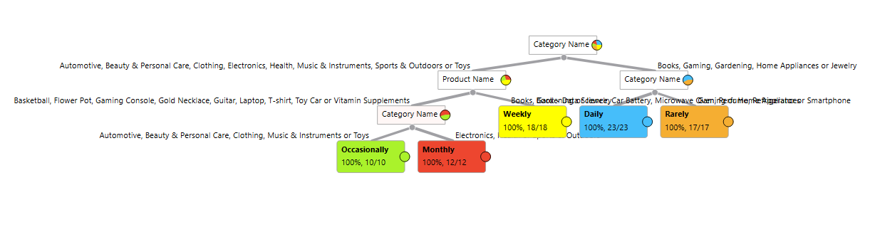

Figure 10: Classification tree

Figure 10 shows that the classification tree has six levels and the leaf nodes contains the values in the target class.

**CONCLUSION:**

In this project, we successfully implemented an end-to-end data-driven approach to classify online shopping users based on their purchasing behavior and demographic attributes. Starting with data collection and preprocessing, we ensured high-quality data through cleaning, normalization, and feature engineering.

We designed and implemented **OLAP schemas** (Star, Snowflake, and Fact Constellation) using **Oracle SQL in SSMS**, followed by data insertion into fact and dimension tables. The schemas were deployed on the **SSAS server**, allowing us to perform OLAP operations such as **Drill-Down, Roll-Up, Slice, Dice**,**and pivot** extracting valuable insights about customer shopping behavior. The results were then visualized using the Orange Tool, effectively showcasing consumer trends.

For classification, we applied machine learning models to categorize online shoppers as OccasionalBuyers, Frequent Buyers, or Loyal Customers based on their shopping patterns. Among the evaluated models, the **Gradient Boosting model** achieved the **best accuracy**, demonstrating its effectiveness in identifying shopping behaviors.

This study highlights the power of OLAP and machine learning in analyzing e-commerceconsumer behavior. The insights gained can be utilized for personalized product recommendations,targeted marketing, dynamic pricing strategies, and inventory management, ultimately improving the **customer experience and business profitability**.

**PART-B: DATA MINING IN DETAIL**

**CHAPTER 1: INTRODUCTION ON DATA MINING METHODOLOGY**

**1.1 Problem Statement :**

Each team is assigned with a dataset randomly to perform data mining using various techniques like Classification, Regression. Clustering and Association Rule Mining.

We need to identify the appropriate technique to perform data mining on assigned dataset.

We are assigned with “servo.tab” dataset.

**1.2 Identification of appropriate Methodology:**

First the dataset assigned to us is loaded into orange tool to known about the dataset. Orange tool identified our dataset to be numerical target dataset. We decided that the dataset would be better for regression.

**1.2.1 Dataset Overview**

The dataset servo.tab contains information about different motors,screw, pgain(Proportional gain), vgain(Velocity gain). The goal is to perform regression with the target variable "CLASS".

**1.2.2 Methodology**

We need the processes the dataset and make sure there are no redundancies test various regression algorithms and then develop the prediction model by training with training dataset and testing it with the testing dataset.

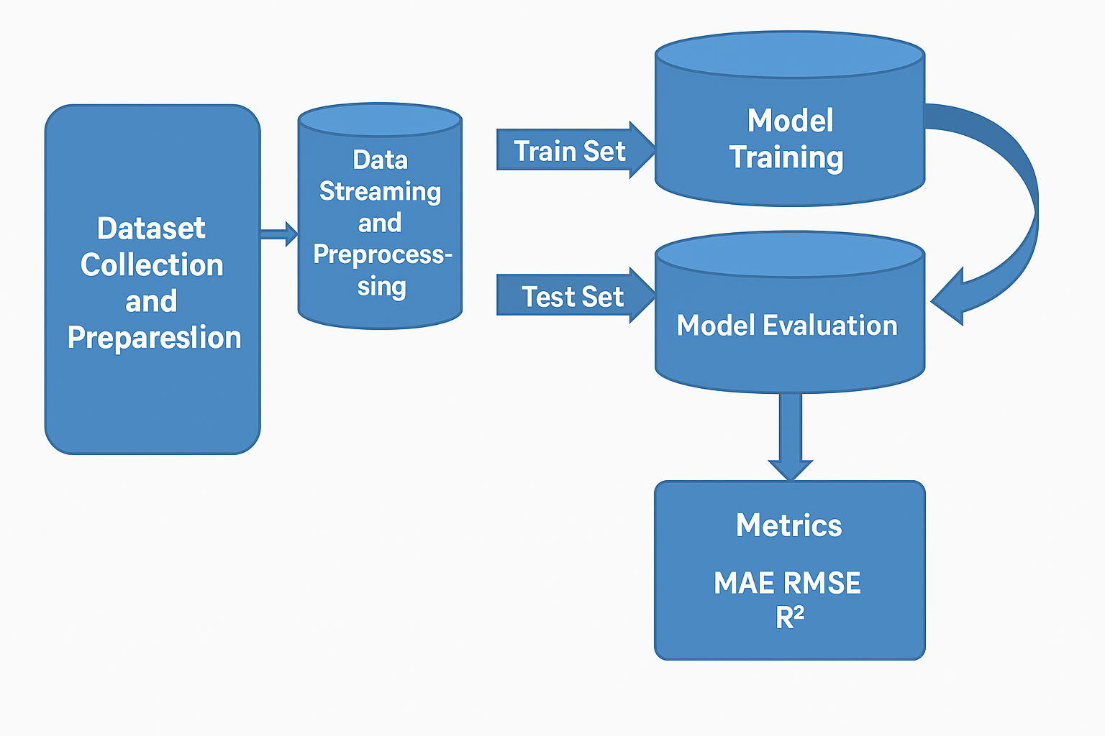

**1.2.3 Machine Learning Models**

We intend to use Supervised Machine Learning models to our dataset by selecting target variable as CLASS. They are Gradient Boosting, Linear Regression, Random Forest, , KNN, SVM.

**1.2.4 Evaluation Metrics**

Since this is a regression problem, we can use:

**Mean Squared Error (MSE):** MSE is the average of the squared differences between the actual and predicted values.

**Root Mean Squared Error (RMSE):** RMSE is the square root of MSE and is expressed in the same unit as the target variable.

**Mean Absolute Error (MAE):** MAE calculates the average of the absolute errors between actual and predicted values.

**R-squared (R² Score):**R² indicates how well the independent variables explain the variance in the dependent variable

#### Block Diagram

The diagram illustrates the machine learning workflow for regression:

1. Source Data undergoes Data Processing and Cleaning to remove inconsistencies and prepare it for analysis.
2. The dataset is split into Training and Testing sets, ensuring proper evaluation.
3. Regression algorithms are applied to the training set, and the best model is selected based on mse from the testing set.

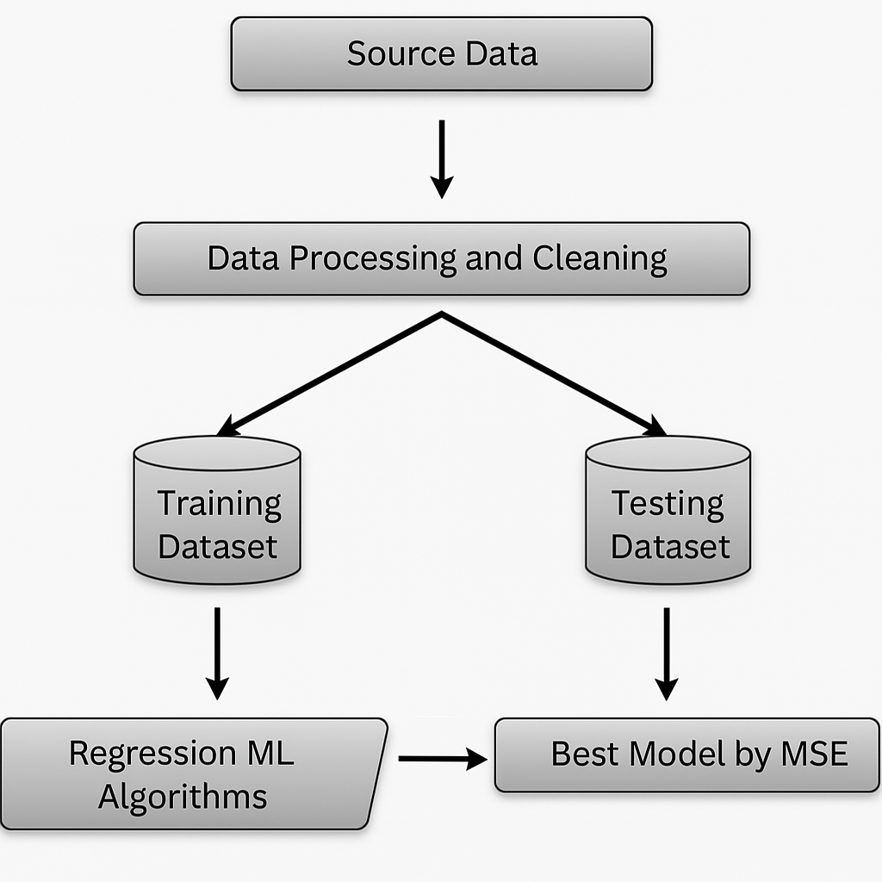

Block Diagram

**CHAPTER 2: ANALYSIS ON THE DATASET**

**TITLE:"Predictive Modeling and Regression Analysis on the Servo Dataset Using Orange”**

**Data Set Description:**

The dataset contains information on **servo system performance**, with multiple records capturing servo motor characteristics and control settings. It includes features like **motor type, screw type, proportional gain, and velocity gain**, which influence the **response time** (target variable). The dataset is used for **regression analysis** to predict servo response time based on given parameters. This helps in optimizing servo control systems for better performance.

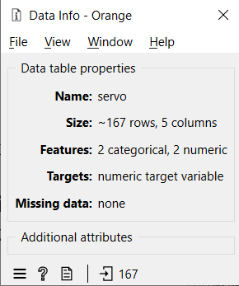

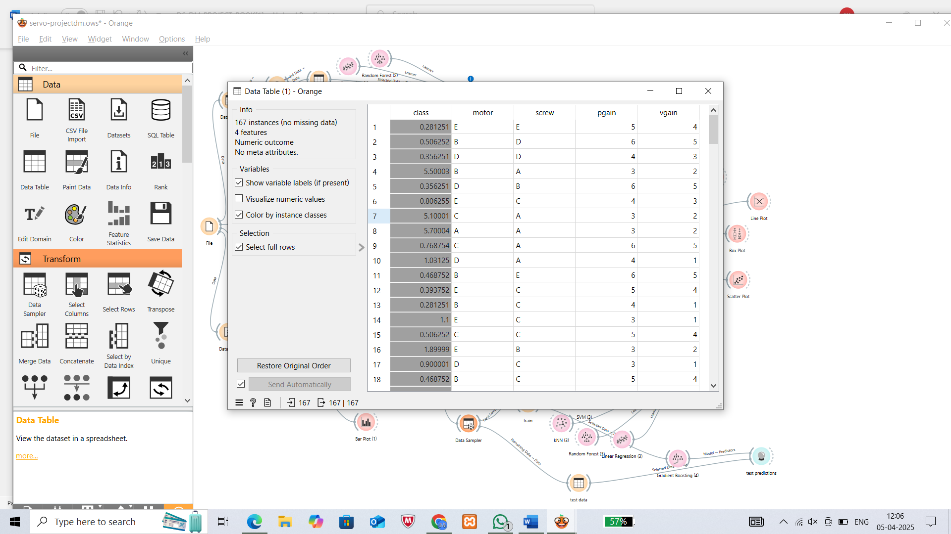

**Dataset Splitting:**

Given the limited dataset, we carefully split the data into **training and test sets** to ensure a robust model evaluation. The dataset was divided as follows:

* **Training Set:** 70% of the data
* **Test Set:** 30% of the data

This split was designed to **maintain a balanced representation of span types** in both sets, allowing us to effectively train and test machine learning models despite the limited number of records.

**Data Visualization:**

For data visualization, we used the Orange Data Mining tool to analyze relationships and correlations among key features like motor type, screw type, proportional gain, and velocity gain. This helped us identify influential attributes affecting servo response time for regression analysis. Before modeling, we examined the distribution of response times to improve model interpretability and performance.

**Data Validation, Cleaning, and Preparation Process**

We meticulously assessed the dataset to ensure its accuracy and readiness for analysis. We began by identifying relevant variables such as motor type, screw type, proportional gain (pgain), velocity gain (vgain), and the servo response time (target variable). Through careful examination, we confirmed there were no missing or duplicate values, ensuring the dataset's integrity for regression modeling.

To enhance the reliability of our model, we applied data preprocessing techniques using the Orange Data Mining tool. Our approach involved:  
• **Normalization of Numerical Features**: Numerical attributes such as pgain and vgain were normalized using the Preprocessing widget to scale them to a uniform [0, 1] range, improving model efficiency and comparability.  
• **Categorical Feature Handling**: Categorical features (motor type and screw type) were retained in their original form, as Orange handles categorical inputs internally.  
• **Target Variable (Response Time**): No transformation was applied to the target variable, as it was already in a usable continuous format.

In real-world scenarios, datasets may not always be a true representation of the population, making data validation essential. We validated the dataset by examining data types (categorical and numerical) and ensuring a consistent distribution of the target variable for reliable regression outcomes.  
To evaluate model performance and tune hyperparameters, we used a data split strategy within Orange, separating the dataset into training and testing sets. This ensured an unbiased evaluation of model fit and generalization performance.

**Machine Learning Techniques and Model Selection**

We implemented and evaluated multiple machine learning algorithms to predict servo response time effectively. The following five regression models were tested using the Test & Score widget in Orange:

1. K-Nearest Neighbors (KNN)
2. Support Vector Machine (SVM)
3. Linear Regression
4. Random Forest
5. Gradient Boosting

The performance of each model was evaluated based on key regression metrics including Mean Squared Error (MSE), Root Mean Squared Error (RMSE), Mean Absolute Error (MAE), and the R² score. The best-performing model was selected based on lowest error values and the highest R², indicating strong predictive accuracy and fit. This model selection process ensured optimal performance for servo response prediction.

**CHAPTER 3: WORKING ON THE DATASET**

**(DEVELOPING PREDICTION MODEL)**

# Orange Data Mining tool description:

The Orange tool is an open-source data visualization and analysis tool that offers a user-friendly interface for performing various machine learning and data mining tasks. It provides a visual programming interface where users can create work flows by connecting different components, such as data loaders, preprocessing tools, and machine learning algorithms.

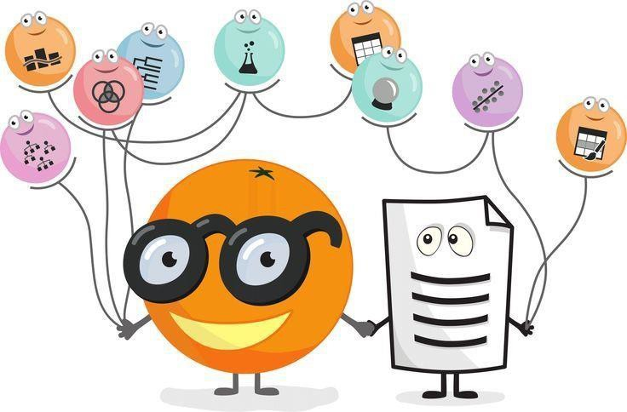

Step-by-Step Guide for Classification Using Orange

**Step 1:** Open Orange Canvas

* Launch the Orange tool.
* Open the Orange Canvas to start creating your workflow.

**Step 2:** Load Dataset

* Drag and drop the "File" widget onto the canvas.
* Click on the "File" widget and then click on the "Browse" button.
* Choose your dataset(e.g.”servo.tab”) and open it.

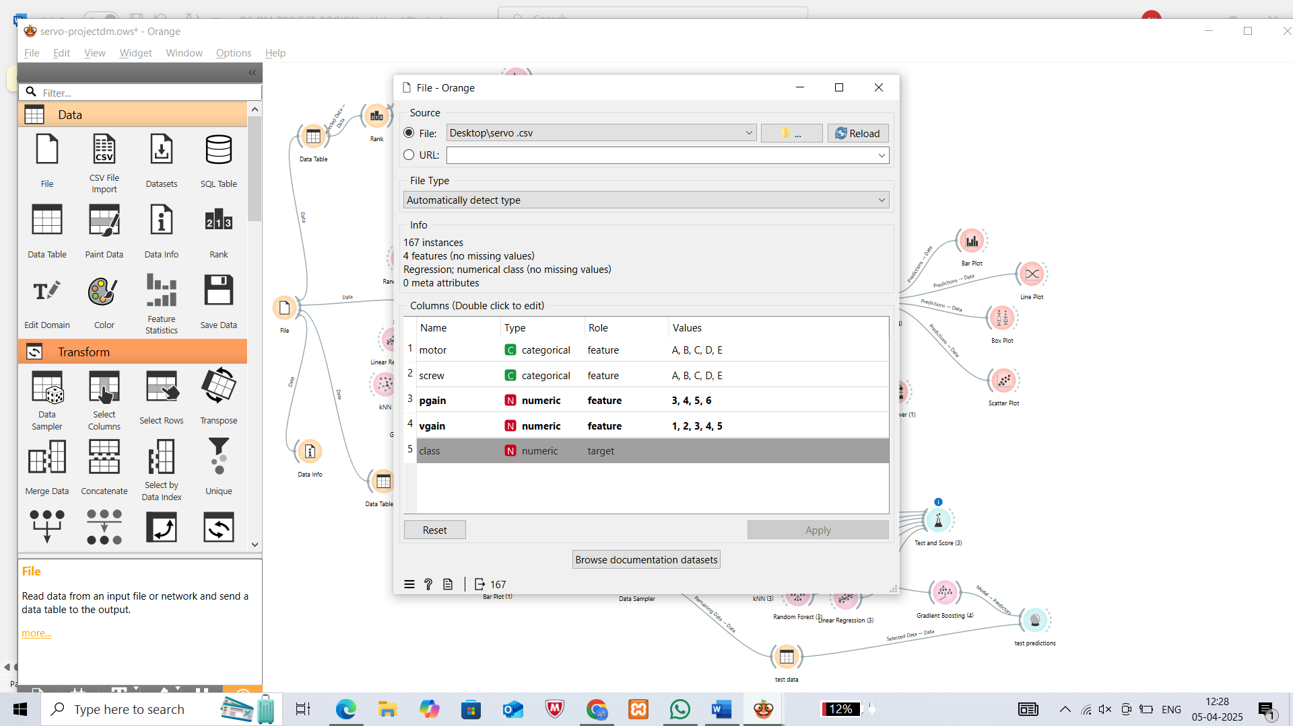

### Step 3: Test the errors and R^2 for various regression algorithms before preprocessing & choose the top five according to their accuracies.

### 

### Step 4: Preprocessing dataset

* Drag and drop the "Preprocess" widget onto the canvas.
* Connect the "File" widget to the "Preprocess" widget.
* There are no missing values in my data
* Select the preprocess technique to normalize the numeric values and Continuize Discrete Variables .

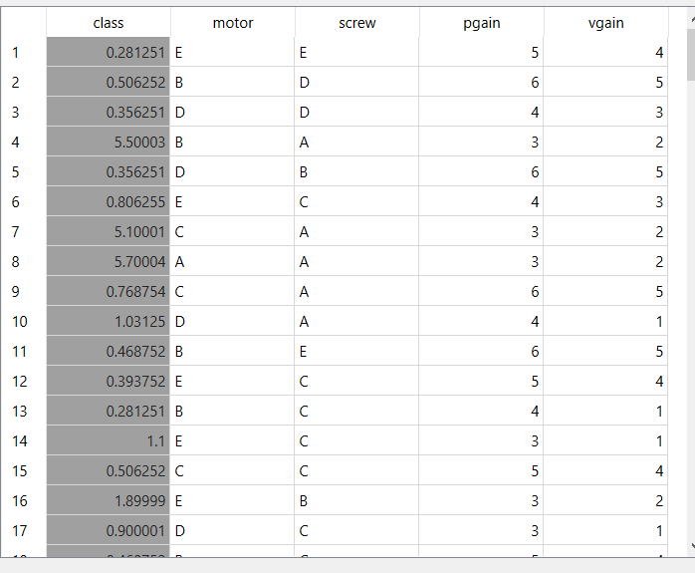

before preprocessing of normalization

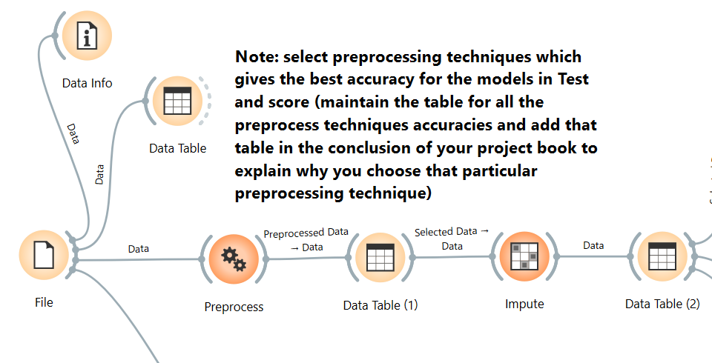

Preprocessing

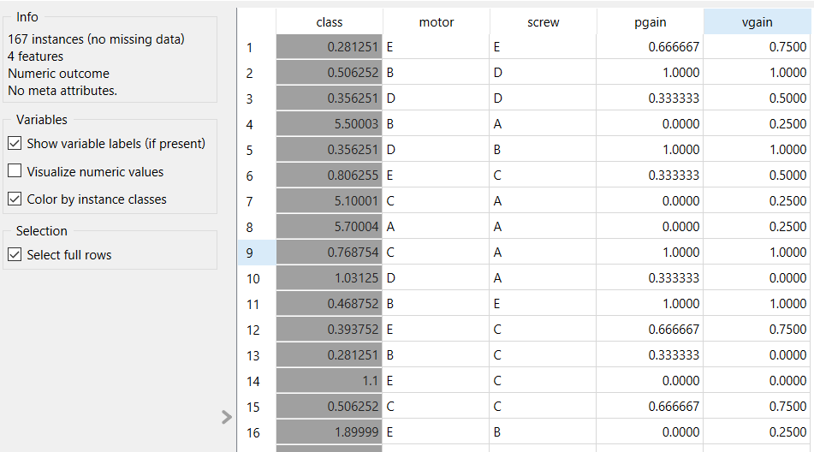

after normalization

And we applied one more preprocessing technique that is, Continuize Discrete Variables-One feature per

value,it gives one value for every feature

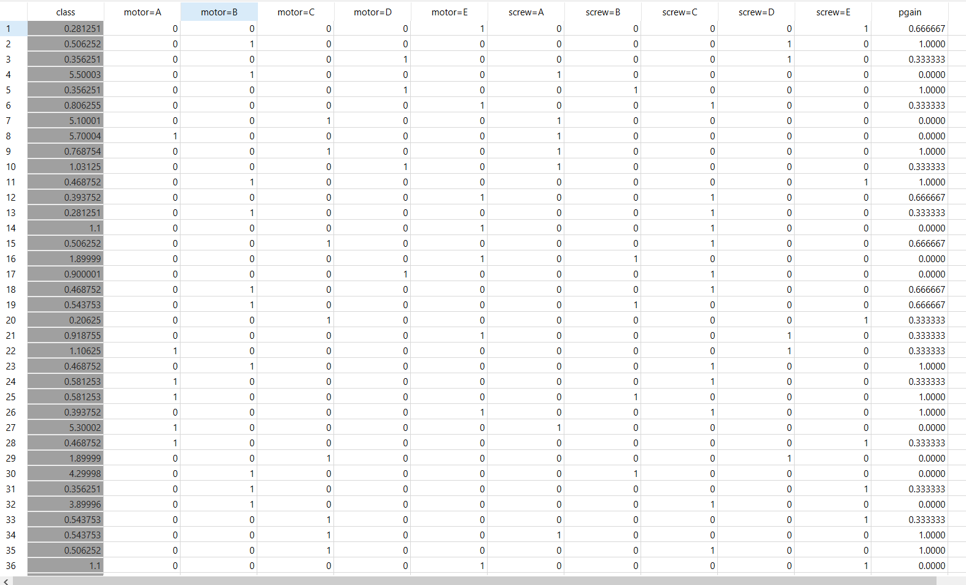

After preprocessing

**Step 5:** Testing accuracy of various regression algorithms

* Drag and drop the "Test & Score" widget
* Connect the "KNN", ”Random Forest”, “Linear Regression”, “Gradient Boosting”, ”SVM” widgets to the "Test & Score" widget.
* Click on the "Test & Score" widget to view the output, including MSE,RMSE,MAE,MAPE,R^2

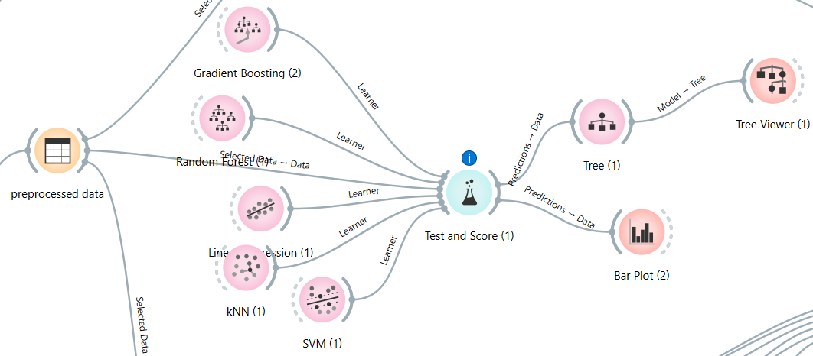

After preprocessing

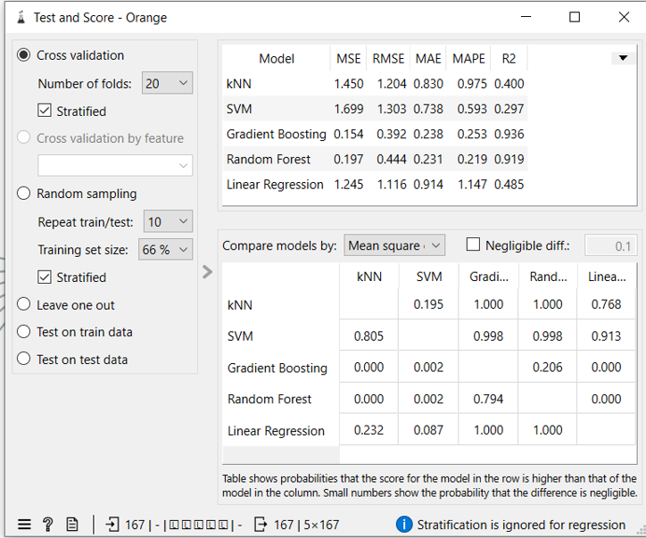

* Make note of all the Errors and R^2 to compare various algorithms before and after preprocessing.
* Apply cross-validation strategy with various fold levels in the "Test & Score" widget to compare results.

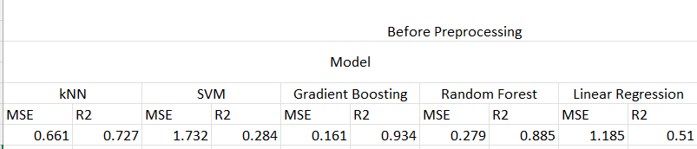

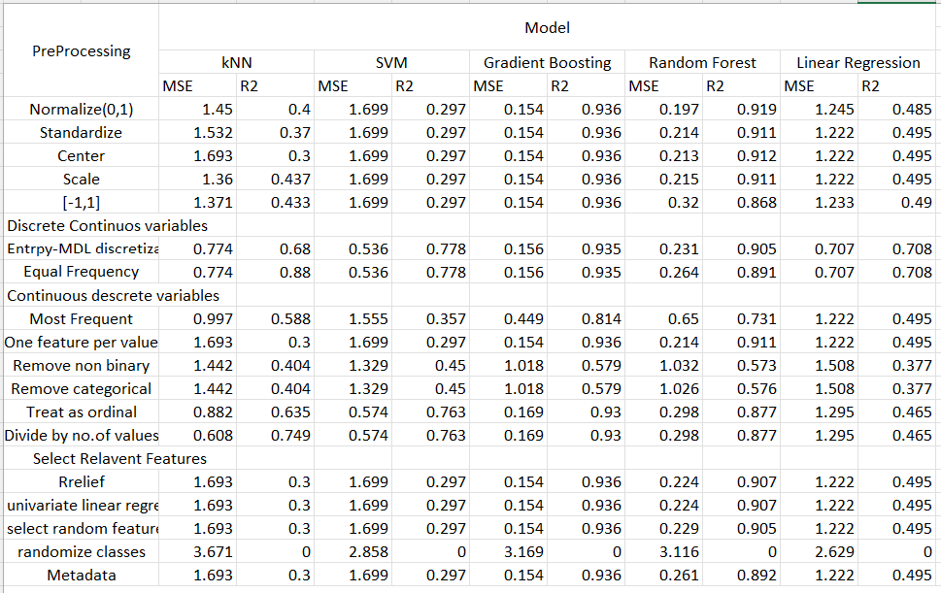

**Analysis Table**

**Step 6:** Developing prediction model for the learning algorithm with best R^2.

* The prediction model needs both training and test data. Based on the training and test data the prediction model can be developed in two ways-

**First way** is by splitting the dataset into training and test datasets using the data sampler

This is clearly explained the figure below:

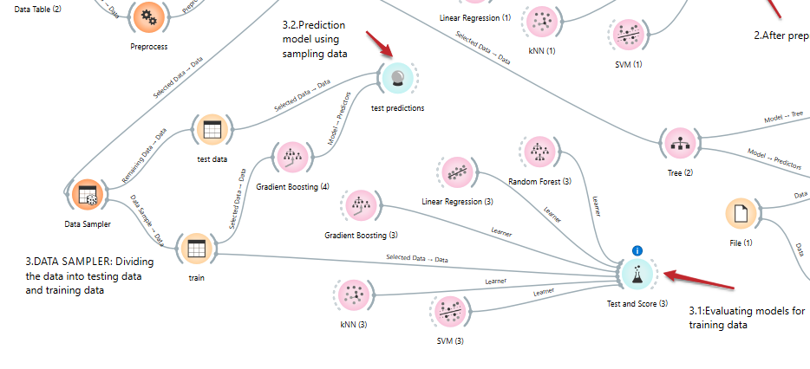

Prediction model by data sampler

**Second way** is by creating a separate test data with the help of available dataset and giving available dataset as training data.

This is explained the figure below:

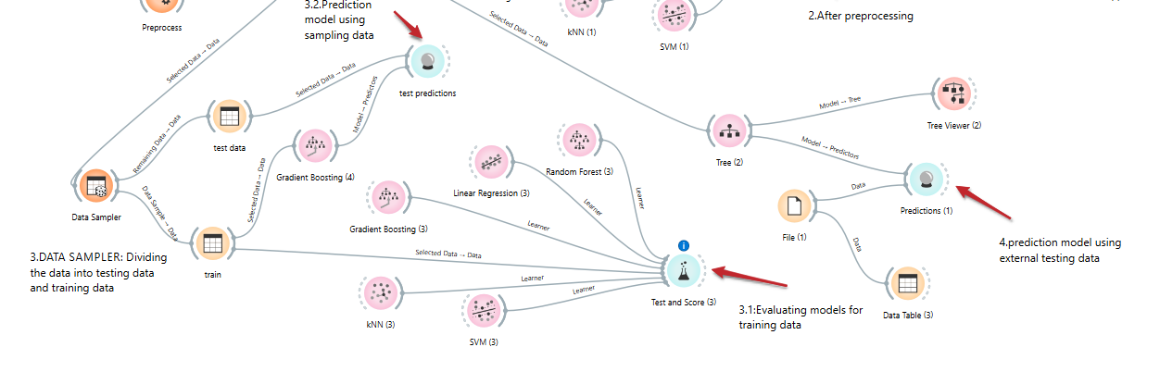

Prediction model by separate train and test data

**Entire Workflow:**

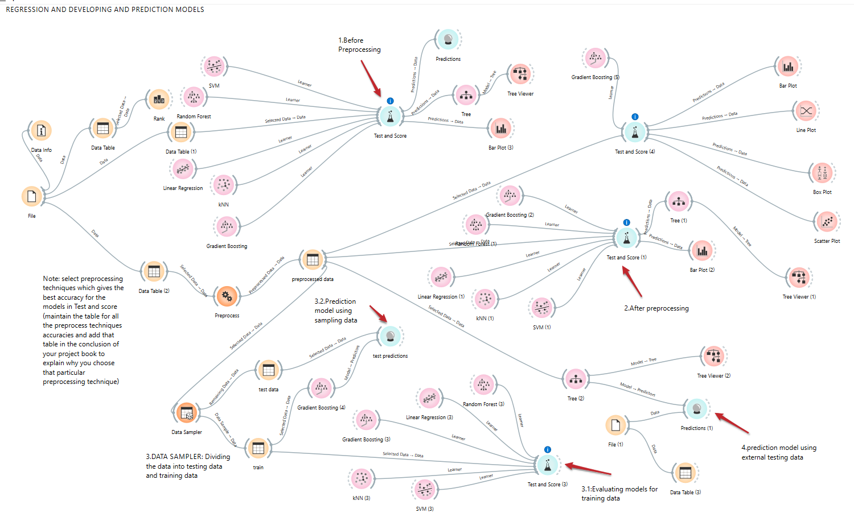

**Step 7:** Perform Visualization for the algorithms. Here We choose barplot to visualize the output in the orange tool. (Since other techniques failed to visualize our dataset properly we preferred Barplot)

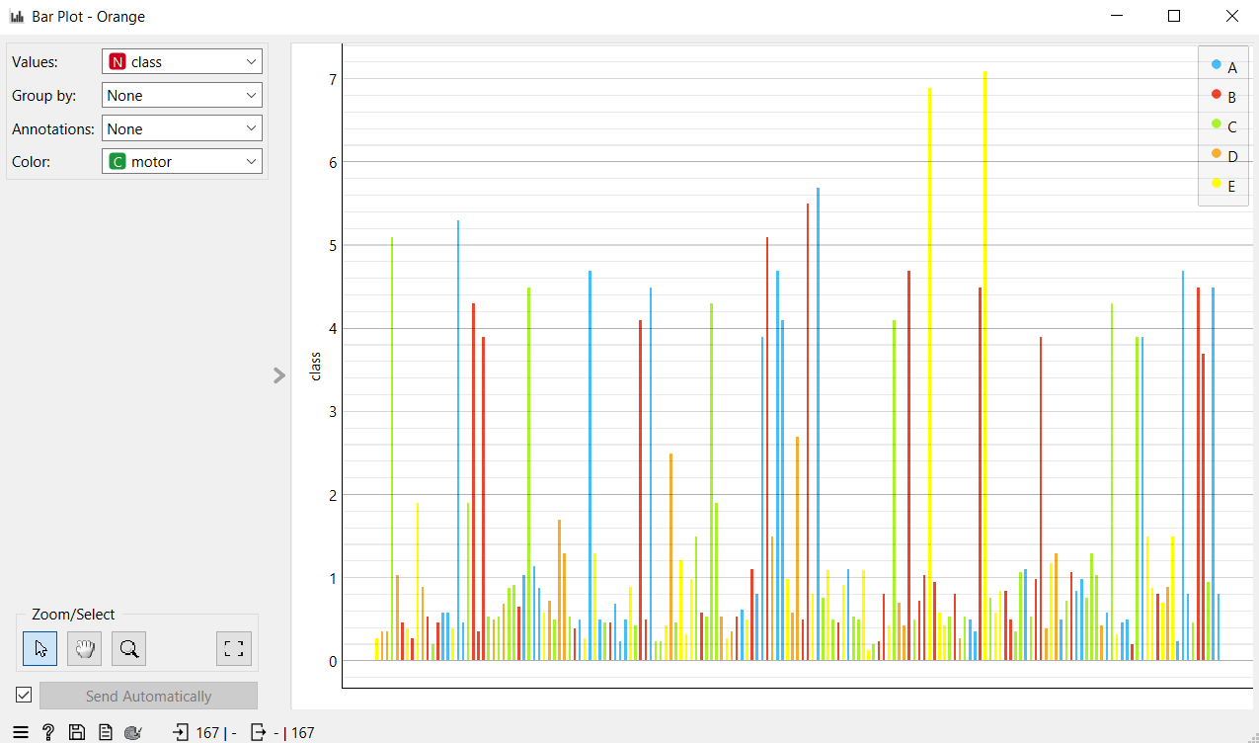

Figure 11: Barplot

**X-axis:** Represents different data instances or rows of motor

**Y-axis:** Represents the values of the “class” variable.

**Color Legend :**Shows categories of the **"motor"** variable with different colors:

Motor A → Blue

Motor B → Red

Motor C → Green

Motor D → Orange

Motor E → Yellow

**Values:** class – This means the height of each bar is determined by the value in the class variable.

**Group by:** None – No grouping of data is applied (e.g., by another variable).

The height of each bar indicates the value of the **class** variable.The **color** of each bar shows the category of the **motor** variable.From the distribution, you can see how the class variable values vary and are distributed across different motor types (A to E).

NOW GROUPING BY SCREWS

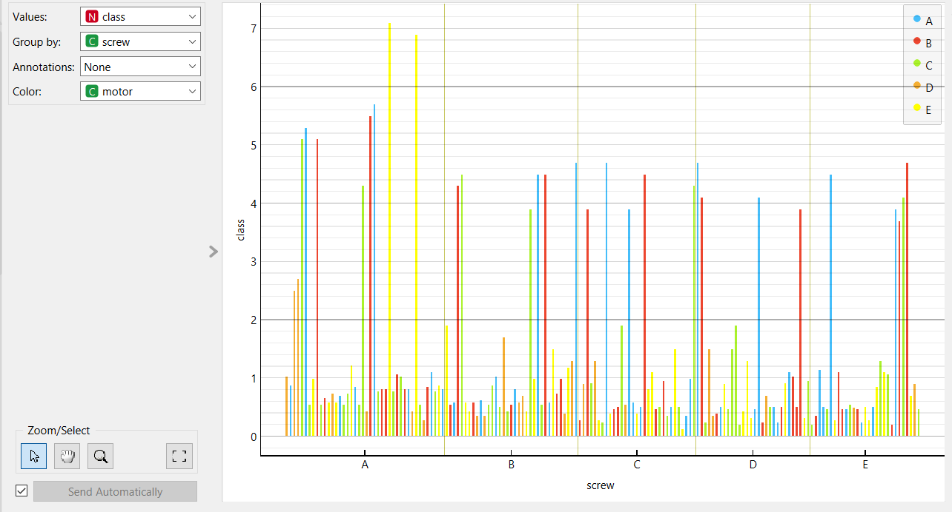

The bars are now grouped into five sections (A to E) along the x-axis, each representing a category in the screw variable.

Within each group, bars still represent values of the class variable.

Color still represents the motor type (A to E), as per the color legend on the right.

You can compare how the class variable is distributed within each screw type.For each screw group (A–E), you can observe the variation in class values across different motors.

For example:

**Screw A** seems to have a higher number of tall bars (higher class values), especially for yellow (motor E) and blue (motor A).

**Screw C** and **D** have a more even distribution across motor types, but generally shorter bars, suggesting lower class values.

**CHAPTER 4: EXPERIMENTAL ANALYSIS**

* Based on the Regression that is shown in the Test & Score widget we choose to evaluate

Gradient Boosting algorithm

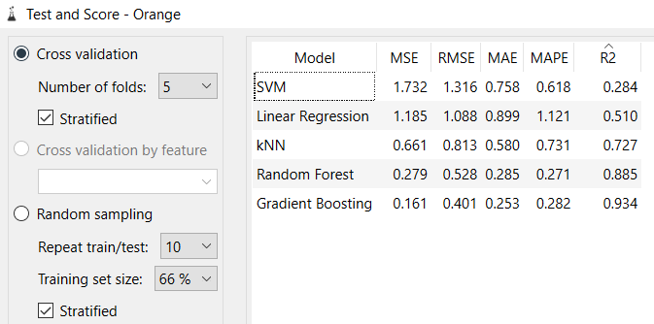

Figure 12: before preprocessing



Figure 13: after preprocessing

Figure 12 shows Test & Score before preprocessing (5-fold Cross Validation, 66% Training Size)

* KNN: 0.727
* Linear Regression: 0.510
* Gradient Boosting: 0.934
* SVM: 0.284
* Random Forest: 0.885

Figure 13 shows Test & Score after preprocessing (5-fold Cross Validation, 66% Training Size)

* KNN: 0.400(Decreased)
* Linear Regression: 0.485(Decreased)
* Gradient Boosting: 0.936 (Increased)
* SVM: 0.297(Increased)
* Random Forest: 0.919 (Increased)

**Comparison Observations**:

After applying **normalization and one feature per value** as a preprocessing steps, the performance of most models **improved**, as reflected in their R² scores:

* KNN performance decreased from 0.727 to 0.400, indicating it may not have benefited from normalization in this dataset.
* Linear Regression slightly decreased from 0.510 to 0.485, showing minimal impact.
* Gradient Boosting saw a slight increase from 0.934 to 0.936, maintaining its position as the best performing model.**-**
* SVM improved modestly from 0.284 to 0.297, suggesting some gain due to normalization.
* Random Forest experienced an increase from 0.885 to 0.919, showing better adaptation after preprocessing.

**Prediction model:**

* By the all observations, we confirmed that Gradient Boosting model is best one ,by using that model we have predicted some test data from sampling
* Here how workflow looks like

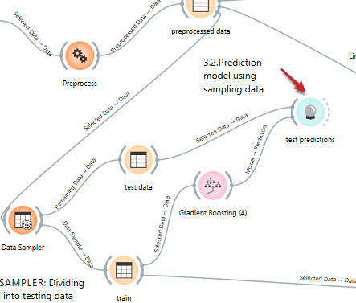

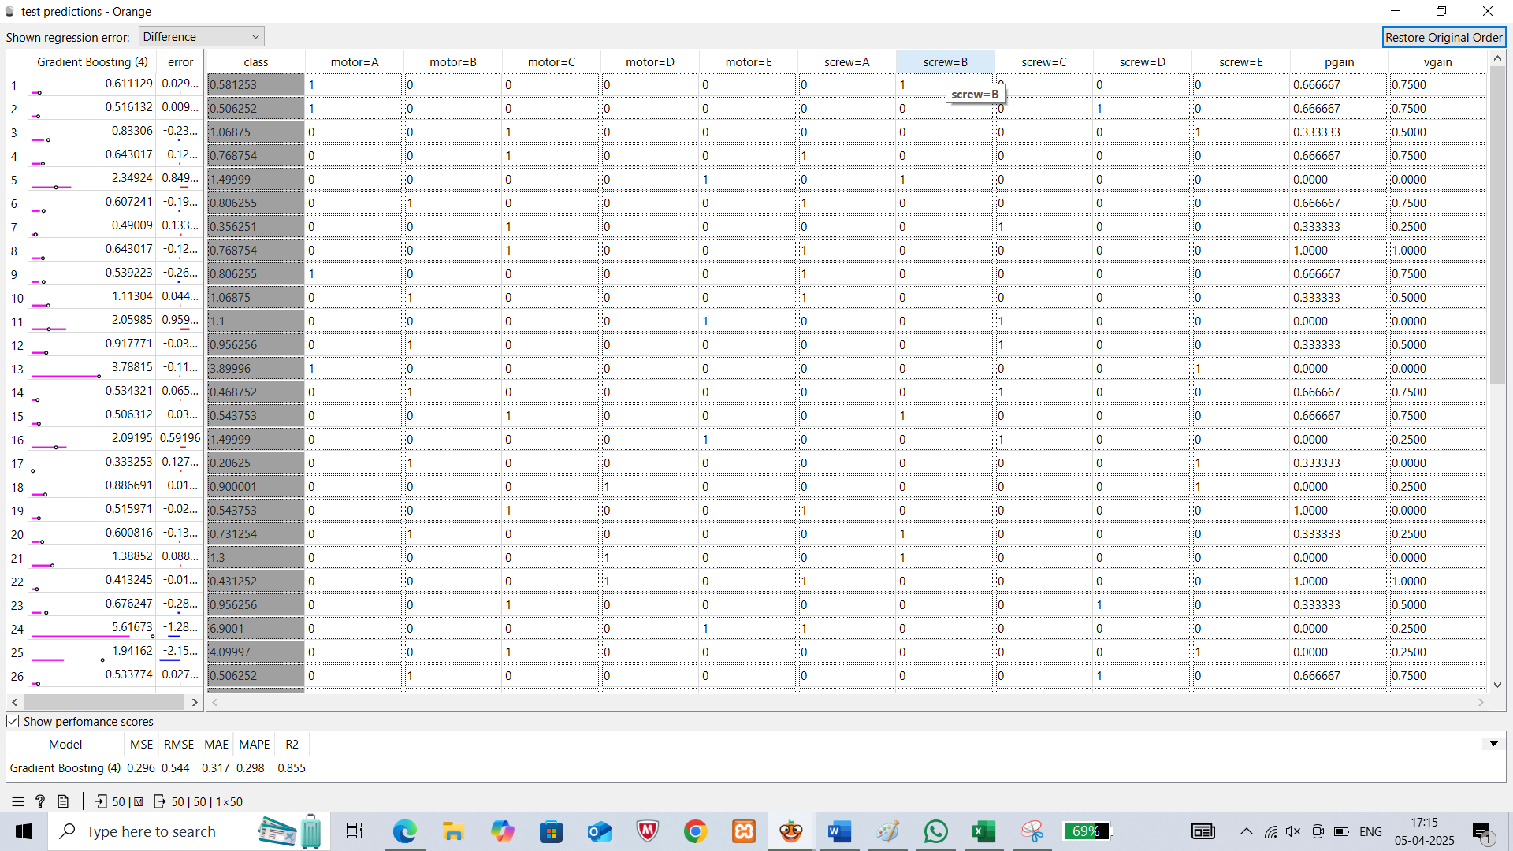

* We have constructed decision tree and we have applied rank to the preprocessed data,the attribute having highest rank is same as the attribute in the root of the decision tree

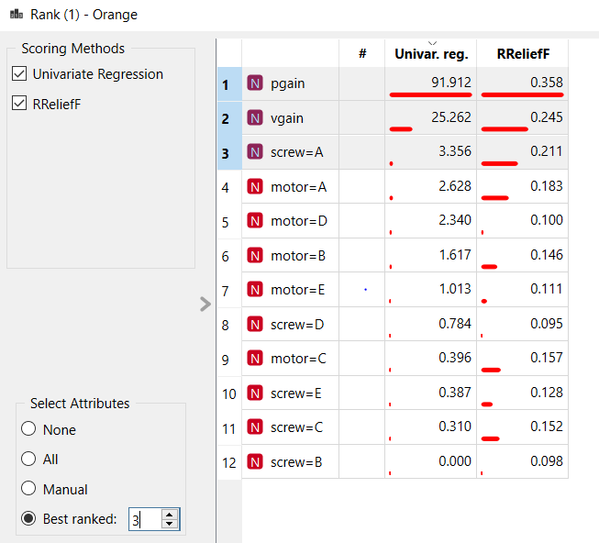

* Here best ranked is pgain

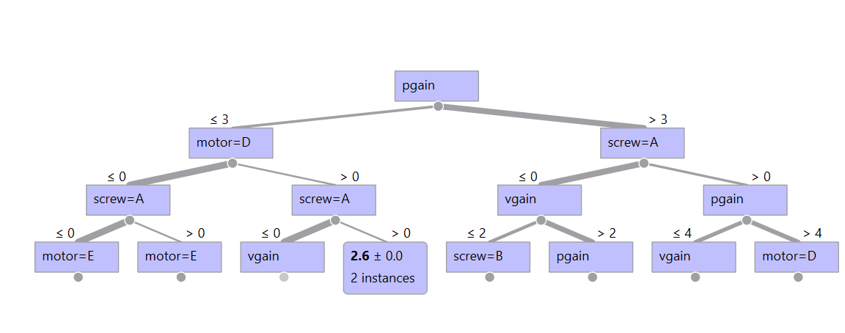

Decision tree

**CONCLUSION:**

In this regression analysis using the Servo dataset, we explored the impact of data preprocessing on theperformance of various machine learning models within the Orange Data Mining environment. The preprocessing techniques included:

* **Normalization** – to scale numeric attributes between 0 and 1.
* **Continuization** – converting discrete categorical features into binary indicators (One Feature Per Value).

**1. Preprocessing Impact:**

Applying both normalization and continuization had mixed effects on model performance:

* Gradient Boosting slightly improved from an R² of 0.934 to 0.936, consistently emerging as the best-performing model.
* Random Forest saw a notable improvement (from 0.885 to 0.919), indicating strong adaptability to the preprocessed feature set.
* SVM improved slightly from 0.284 to 0.297, suggesting a modest benefit from normalization and binary encoding.
* Linear Regression showed a minor drop (from 0.510 to 0.485), reflecting minimal sensitivity to preprocessing.
* KNN experienced a significant decrease in performance (from 0.727 to 0.400), indicating that it may not be well-suited to normalized or binary-encoded data in this context.

**2. Model Performance Summary:**

| **Model** | **R² Before Preprocessing** | **R² After Preprocessing** |
| --- | --- | --- |
| Gradient Boosting | 0.934 | 0.936 |
| Random Forest | 0.885 | 0.919 |
| KNN | 0.727 | 0.400 |
| Linear Regression | 0.510 | 0.485 |
| SVM | 0.284 | 0.297 |

**3. Model Recommendation:**

* Gradient Boosting remains the top choice, with stable and high predictive power both before and after preprocessing.
* Random Forest is a strong alternative, showing consistent improvement post-preprocessing.
* KNN, although effective initially, does not handle the combined preprocessing well and may not be ideal for this dataset.
* SVM and Linear Regression showed only slight changes, indicating moderate compatibility with the data transformations.

**4. Future Scope with the Servo Dataset:**

* Explore More Regressors: Use XGBoost, CatBoost, or Neural Networks to potentially improve predictive accuracy.
* Hyperparameter Tuning: Perform Grid Search or Randomized Search for all models to optimize performance.
* Dimensionality Reduction: Apply techniques like PCA after continuization to reduce redundancy introduced by binary expansion.
* Interpretability: Use SHAP values or feature importance plots to interpret model decisions and understand key servo parameters.
* Deployment: Integrate the final model into a servo tuning assistant for engineers to dynamically estimate optimal configurations.

**PART C: FINAL ANALYSIS**

**1. Introduction**

In data mining and machine learning, dataset selection plays a crucial role in determining the effectiveness of the models applied. This study analyzed two different experimental setups:

Part A, which used a generated dataset, and

Part B, which used an online dataset collected from external sources.

This section aims to integrate insights from both experiments and provide final conclusions regarding their performance, applicability, and limitations.

**2. Key Observations from Experimental Analysis**

**2.1. Data Characteristics and Preprocessing**

One of the fundamental differences between the two parts was the nature of the dataset used.

* Generated dataset (Part A) was pre-structured, leading to minimal preprocessing efforts. There were some missing values or inconsistencies, making it easier for models to achieve high accuracy with basic tuning.
* Part-A dataset is suitable for classification
* Online dataset (Part B) required 2 preprocessing techniques. This extra preprocessing influenced the model performance significantly.
* Part-B dataset is suitable for regression
* Despite the challenges of Part B, working with real-world datasets helps build more generalized models that can perform well on unseen data.

**2.2. Model Performance Analysis**

* Across both experiments, various classifiers (KNN, Naïve bayes,Linear Regression, Gradient Boosting, SVM, and Random Forest, etc…) were tested, and their performances were evaluated using classification accuracy (CA), , and confusion matrices.
* Regressors(KNN,Logistic Regression,Gradient Boosting,SVM,Random Forest,etc..)were tested ,and their performances were evaluated using R^2

**2.3. Key Findings from Model Comparisons**

* Gradient Boosting consistently performed the best across both datasets, benefiting from its ability to classify instances effectively when properly tuned.
* Support Vector Machine (SVM) achieved the highest classification performance (AUC: 0.999), highlighting its strength in handling high-dimensional data with a clear margin of separation.
* Random Forest showed strong performance in regression (R²: 0.919) and competitive classification metrics, improving notably after preprocessing, which emphasizes its reliance on high-quality input features.
* K-Nearest Neighbors (KNN) performed the weakest overall, especially in classification (Accuracy: 58%, MCC: 0.479) and regression (R²: 0.400), indicating limitations with noisy or high-dimensional datasets.
* SVM underperformed in regression (R²: 0.297), suggesting it's less suited for the regression problem in this context, possibly due to sensitivity to feature scaling or the lack of nonlinear kernels.
* Overall, tree-based models (Gradient Boosting & Random Forest) demonstrated superior performance when paired with proper data preprocessing, making them reliable choices for both classification and regression tasks.

**3. Preprocessing Differences**

**Part A: Minimal Preprocessing**

* Data was structured and balanced.
* models performed well **without extensive preprocessing**.
* Features were designed to align with model input requirements.

**Part B: Extensive Preprocessing Required-Servo Dataset**

* Normalization and Continuization were applied to align feature ranges and convert categorical variables into binary attributes. This ensured that models sensitive to scale and input format (e.g., SVM, KNN) could handle the data appropriately.
* While the Servo dataset is relatively small, feature encoding (One Feature Per Value) increased dimensionality. Therefore, careful feature handling was necessary to avoid sparsity and ensure efficient learning.
* Model sensitivity to preprocessing varied:
  + Random Forest and Gradient Boosting adapted well, showing improved R² scores.
  + KNN performance declined after preprocessing, indicating that normalization and binary encoding may not suit distance-based models in this dataset.
  + Linear Regression showed minimal change, while SVM had a slight improvement.

1. **Findings from Bar plot Analysis**

Part A: Online Shopping Dataset

* Daily and Weekly shoppers have the highest total spending.
* Rarely and Monthly shoppers spend the least.
* Shopping frequency strongly influences spending behavior

Part B: Servo Dataset

* Class values vary significantly across motor types, especially for D and E.
* Motors A, B, and C show more consistent class outputs.
* No clear dominant motor-class link, suggesting possible need for feature engineering.

**5. Conclusion**

This study compared the experimental analysis of a classification task using the Online Shopping dataset (Part A) and a regression task using the Servo dataset (Part B). Key takeaways include:

Part A achieved higher accuracy faster due to well-structured data.

Part B achieved high regression accuracy, with Gradient Boosting and Random Forest performing best due to their ability to handle structured data effectively.

Gradient Boosting emerged as the most consistent model across both tasks, demonstrating strong generalization in both regression and classification

**REFERENCES**

1. **Classification (General + Applied)**
   * "Pattern Recognition and Machine Learning" by Christopher M. Bisho
   * Data Mining: Concepts and Techniques" by Jiawei Han, Micheline Kamber, Jian Pei
   * "Introduction to Data Mining" by Pang-Ning Tan, Michael Steinbach, and Vipin Kumar
2. **Regression**
   * "The Elements of Statistical Learning" by Hastie, Tibshirani, and Friedman.
   * "An Introduction to Statistical Learning" by James, Witten, Hastie, Tibshirani
   * Applied Linear Regression" by Sanford Weisberg
3. **Books and References for Understanding and Using Servo Datasets**
   * "Data Mining: Practical Machine Learning Tools and Techniques" by Ian H. Witten, Eibe Frank, Mark A. Hall
   * "Machine Learning with R" by Brett Lantz.
4. **Core Data Mining Books** (with online shopping relevance):
   * "Data Mining: Concepts and Techniques" by Jiawei Han, Micheline Kamber, and Jian Pei
   * "Web Data Mining: Exploring Hyperlinks, Contents, and Usage Data" by Bing Liu
   * "Data Mining Techniques: For Marketing, Sales, and Customer Relationship Management" by Gordon S. Linoff and Michael J.A. Berry
   * "Mining of Massive Datasets" by Anand Rajaraman and Jeffrey D. Ullman

**SESHADRI RAO GUDLAVALLERU ENGINEERING COLLEGE**

(An Autonomous Institute with Permanent Affiliation to JNTUK, Kakinada)

Seshadri Rao Knowledge Village, Gudlavalleru

**Department of Computer Science and Engineering**

### Program Outcomes (POs)

#### Engineering Graduates will be able to:

1. **Engineering knowledge**: Apply the knowledge of mathematics, science, engineering fundamentals, and an engineering specialization to the solution of complex engineering problems.
2. **Problem analysis**: Identify, formulate, review research literature, and analyze complex engineering problems reaching substantiated conclusions using first principles of mathematics, natural sciences, and engineering sciences.
3. **Design/development of solutions**: Design solutions for complex engineering problems and design system components or processes that meet the specified needs with appropriate consideration for the public health and safety, and the cultural, societal, and environmental considerations.
4. **Conduct investigations of complex problems**: Use research-based knowledge and research methods including design of experiments, analysis and interpretation of data, and synthesis of theinformation to provide valid conclusions to meet the desired needs.
5. **Modern tool usage**: Create, select, and apply appropriate techniques, resources, and modern engineering and IT tools including prediction and modeling to complex engineering activities with an understanding of the limitations.
6. **The engineer and society**: Apply reasoning informed by the contextual knowledge to assess societal, health, safety, legal and cultural issues and the consequent responsibilities relevant to the professional engineering practice.
7. **Environment and sustainability**: Understand the impact of the professional engineering solutions in societal and environmental contexts, and demonstrate the knowledge of, and need forsustainable development.
8. **Ethics**: Apply ethical principles and commit to professional ethics and responsibilities and normsof the engineering practice.
9. **Individual and team work**: Function effectively as an individual, and as a member or leader in diverse teams, and in multidisciplinary settings.
10. **Project management and finance**: Demonstrate knowledge and understanding of the engineering and management principles and apply these to one’s own work, as a member and leader in a team, to manage projects and in multidisciplinary environments.
11. **Communication**: Communicate effectively on complex engineering activities with the engineering community and with society at large, such as, being able to comprehend and rite
12. **Life-long learning**: Recognize the need for, and have the preparation and ability to engage in independent and life-long learning in the broadest context of technological change.

### Program Specific Outcomes (PSOs)

PSO1 : Design, develop, test and maintain reliable software systems and intelligent systems.PSO2 : Design and develop web sites, web apps and mobile apps.

**PROJECT PROFORMA**

|  |  |  |  |  |
| --- | --- | --- | --- | --- |
| **Classification of**  **Project** | **Application** | **Product** | **Research** | **Review** |
| √ |  |  |  |

**Note: Tick Appropriate category**

|  |  |
| --- | --- |
| **Data Mining Outcomes** | |
| Course Outcome (CO1) | Describe fundamentals, and functionalities of data mining system and data preprocessing techniques. |
| Course Outcome (CO2) | Illustrate the major concepts and operations of multi  dimensional data models. |
| Course Outcome (CO3) | Analyze the performance of association rule mining  algorithms for finding frequent item sets from the large databases. |
| Course Outcome (CO4) | Apply classification algorithms to solve classification problems. |
| Course Outcome (CO5) | Use clustering methods to create clusters for the given data set. |

**Mapping Table**

|  |  |  |  |  |  |  |  |  |  |  |  |  |  |  |  |
| --- | --- | --- | --- | --- | --- | --- | --- | --- | --- | --- | --- | --- | --- | --- | --- |
| **CS3509 : DATA MINING** | | | | | | | | | | | | | | | |
| **Course Outcomes** | **Program Outcomes and Program Specific Outcome** | | | | | | | | | | | | | | |
| **PO 1** | **PO 2** | **PO 3** | **PO 4** | **PO 5** | **PO 6** | **PO 7** | **PO 8** | **PO 9** | **PO 10** | **PO 11** | **PO 12** |  | **PSO 1** | **PSO 2** |
| CO1 | 1 | 1 |  |  |  |  |  |  |  |  |  | 1 |  |  |  |
| CO2 | 1 |  |  |  |  |  |  |  |  |  |  | 1 |  |  |  |
| CO3 | 2 | 3 | 2 |  |  |  |  |  |  |  |  | 2 |  | 1 |  |
| CO4 | 2 | 2 | 3 | 2 |  |  |  |  |  |  |  | 2 |  | 2 |  |
| CO5 | 1 | 2 | 3 | 1 |  |  |  |  |  |  |  | 2 |  | 1 |  |

**Note: Map each Data Mining outcomes with POs and PSOs with either 1 or 2 or 3 based onlevel of mapping as follows:**

1-Slightly (Low) mapped 2-Moderately (Medium) mapped 3-Substantially (High) mapped